C/O/100138C

# EFRATOM

 Time & Frequency Products, Inc

DESCRIPTION AND

OPERATION MANUAL

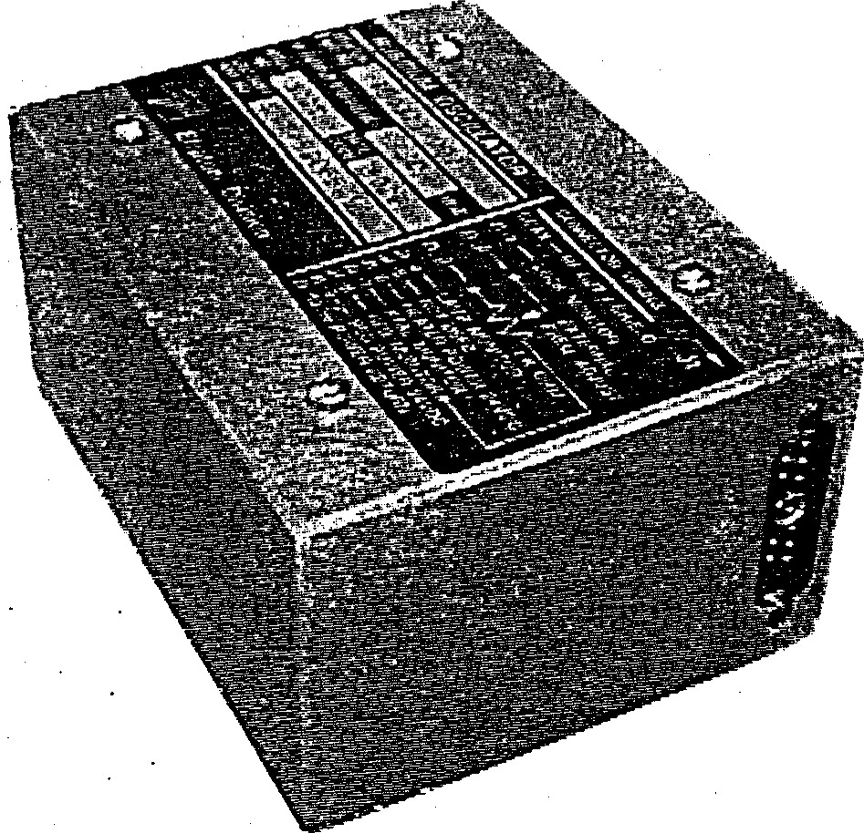

SUBMINIATURE RUBIDIUM OSCILLATOR

MODEL FRS 

TABLE OF CONTENTS

|  |  |
| --- | --- |
| CHAPTER/PARAGRAPH  1. INTRODUCTION & SPECIFICATIONS | PAGE |
| 1.1. Introduction | 1-1 |
| 1.2. Scope | 1-1 |
| 1.3. Connections | 1-1 |
| 1.4. Electrical Protection | 1-1 |
| 1.5. Available Options | 1-1 |
| 1.6. Specifications  2 . INSTALLATION & OPERATION | 1-1 |
| 2.1. Introduction | 2-1 |
| 2.2. Shipping and Receiving Information | 2-1 |
| 2.3. Mounting | 2-1 |
| 2.4. Power Requirements | 2-1 |
| 2.5. Installation Considerations | 2-1 |
| 2.6. Signal Inputs & Outputs | 2-2 |
| 2.7. Normal operation | 2-2 |
| 2.8. Functional Operation Test Equipment | 2-2 |
| 2.9. Operational Frequency Accuracy Test  2.10. Short Term Stability Test (Allan Variance)  3 . THEORY OF OPERATION | 2-3 |
| 3.1. Introduction | 3-1 |
| 3.2. General Theory | 3-1 |
| 3.3. Detailed Circuit Descriptions | 3-6 |
| 3.3.1. Physics Package | 3-6 |
| 3.3.2 Servo Board Assembly | 3-10 |
| 3.3.3. Crystal Oscillator (VCXO) | 3-12 |
| 3.3.4. Multiplier Assembly | 3-12 |
| 3.3.5. Power Supply  LIST OF ILLUSTRATIONS | 3-13 |
| FIGURE TITLE | PAGE |
| 2-1. Cannon Connector Jl and Pin Arrangement | 2-2 |
| 2-2. Operational Frequency Accuracy Test Setup | 2-3 |
| 3-1. Simplified Block Diagrarn of Rubidium Atomic Standard | 3-2 |
| 3-2. Derivation of Modulation Signal | 3-2 |
| 3-3. Simplified Block Diagram of Physics Package  34. Optical Pumping Process | 3-3 |
| 3-5. Electrical Analog of Physics Package | 3-5 |
| 3-6. Detailed Block FRS | 3-7 |
| 3-7. TPI Phase and-Amplitude Indications  LIST OF TABLES | 3-11 |
| FIGURE TITLE | PAGE |
| 1-1. Specifications, FRS | 1-2 |
| 2-1. Functional Operation Test Equipment  APPENDIX  List of Drawings | 2-2 |
| Assembly Drawings i | A-2/A-28 |

## CHAPTER 1

INTRODUCTION AND SPECIFICATIONS

1-1. INTRODUCTION.

The Efratom Model FRS Rubidium Standard is a sub-miniature, atomic resonance-controlled oscillator that provides an extremely stable signal of 2.048 ITL, 5 MHz, or 10 MHz (TTL or sinusoidal). The FRS-C is designed for instruments and equipment requiring an extremely stable and precise frequency operating in commercial/industrial environmental conditions. The FRS-N is designed primarily for use in high-performance communication and navigation systems with more stringent environmental conditions.

1-2. SCOPE.

i This manual contains information regarding the operation and field maintenance of the FRS. Chapters 1 and 2 contain general information concerning the unit. It is recommended that these chapters be read prior to attempting operation of the unit. Chapter 3 presents a general theory of operation for a technician or engineer who requires a better understanding of the unit's operation. Outline and assembly drawings, parts lists and schematic diagrams are contained in the Appendix. 

1-3. CONNECTIONS.

All necessary connections for input and output signals are externally accessible. Output signal, power, frequency adjustment, and built-in-test (BIT) functions are provided by a Cannon connector that mates with P/N DAMI IWIS and DM 53740-5000.

1-4. ELECTRICAL PROTECTION. 

The unit is protected against reverse polarity input power by both an internal fuse and diode. The output signal is short-circuit protected.

1-5. AVAILABLE OPTIONS.

Optional output frequencies include the following: 5 MHz at 1.5 Vrrns into a 50 ohm load, 2.048, 5 or



10 MHz '1%.

1-6. SPECIFICATIONS. 

The FRS 1 •daystabüity (IE-I()) assumes  of 25 a warm-up time of forty-eight hours minimum, preceded by a maximum off time of seventy-two hours; or a warm-up time of three days with an off time of one month. After seven days of continuous operation, the one day  stability is 4E-11. Table 1-1 lists the specifications for the FRS Model C. Table 1-2 lists the specifications for the FRS Model N.

TABLE 1-1. SPECIFICATIONS, FRS-C

ELECTRICAL FRS-C

Output: EXAMPLE PART NUMBER

FRS-C-1A8A4C

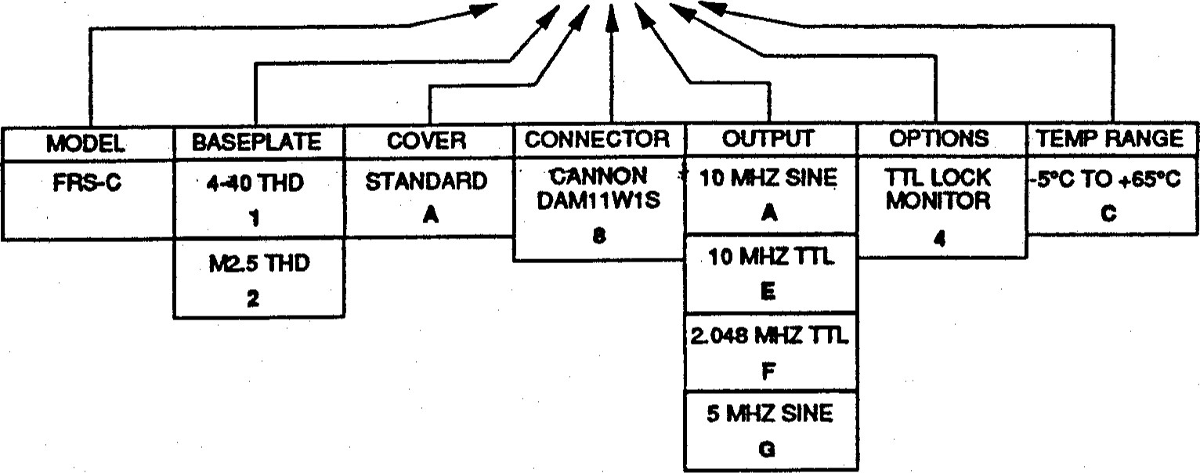

|  |  |
| --- | --- |
| Amplitude (Sine): | 0.5 Vrrns +30/-10% into 50 ohm resistive load |
| Amplitude CITL): | Low: O to +0.8V, High: +3.5 to +5.5V, into 50 resistive load. |
| Accuracy Setting at Shipment: | ±5E-11 (25 0C) (Accuracy after 1 year): IE-9/Year |
| Input Voltage Range: | 22 to 30 Vdc |
| Power-steady State: | 12 W @ 24 Vdc at 25 0C Base Plate |
| At tum on: | 2.0 A peak |
| Input Voltage Sensitivity:  Warm-up Characteristics: | 5E-11 (for Vdc) |
| Time to lock: | 4 minutes |
| Minutes/Freq@ 250C: | 6 minutes/1E-9 |

Long Term Drift: 5E-11/M0*, ±5E-10/Yr

I-Day Stability:

 Short-Term Stability: (5 & 10 N*fHz outputs only)

|  |  |
| --- | --- |
| 1.0 Second (Allan Var.) | IE-IO |
| 10 sec. (Allan var.) | 3.16E-11 |
| 100 Sec. (Allan var.) | IE-II |
| Phase Noise (SSB 1 Hz BW) : | -70dBcAHz at IHz, -1 IOdB cNHz at IOOHz,  -130 dBcNHz at 1 KHz |

Hannonic/Non-Harmonic Distortion: 10 MHz = -40 dBc (sine)/ -70 dBc•,

5 = -40 dBc/-60 dB

|  |  |  |  |  |  |  |  |  |  |  |  |  |  |  |  |  |  |  |  |
| --- | --- | --- | --- | --- | --- | --- | --- | --- | --- | --- | --- | --- | --- | --- | --- | --- | --- | --- | --- |
| |  |  | | --- | --- | | Frequency Trim Range: | ±1E-9 minimum | | Frequency Retrace: | 5E-11 | | Setting Resolution: | IE-II | | Magnetic Field Sensitivity: | < 4E-13/A In-I (worst case) | | Electrical Protection:  ENVIRONMENTAL | Intemal diode protects against reverse polarity connection. Rf output/BIT short-circuit protected. | | Operating Temperature: | 3E-10 from S OC to +55 0C Amb. (65 0C Max baseplate) | | Storage Temperature (non-ops): | -55 0 C to +85 0C | | Hurnidity: | 95 % RH | | Altitude, Vibration, Shock: | NflL-T-28800 Type m, Class 5 | |  |

PHYSiCAL

|  |  |
| --- | --- |
| Size (inches h/w/d): | 2.0 x 3.0 x 4.0 (5.1 x 7.6 x 10.2 cm) |
| Weight: | 1.2 lbs (0.55 kg) |
| Connectors: | Mate with Cannon Series DAMI I WIS |
| Baseplate Threads: | (STD) 4-40 (M2.5 option) |
| Warranty: | 12 months |

* After 1 month of continuous operation ** Refer to Section 1-6.

TABLE 1-2 SPECIFICATIONS, FRS-N

### FRS-N

|  |  |
| --- | --- |
| ELECTRICAL | EXAMPLE PART NUMBER FRS-N-l A8A4B |

Output: 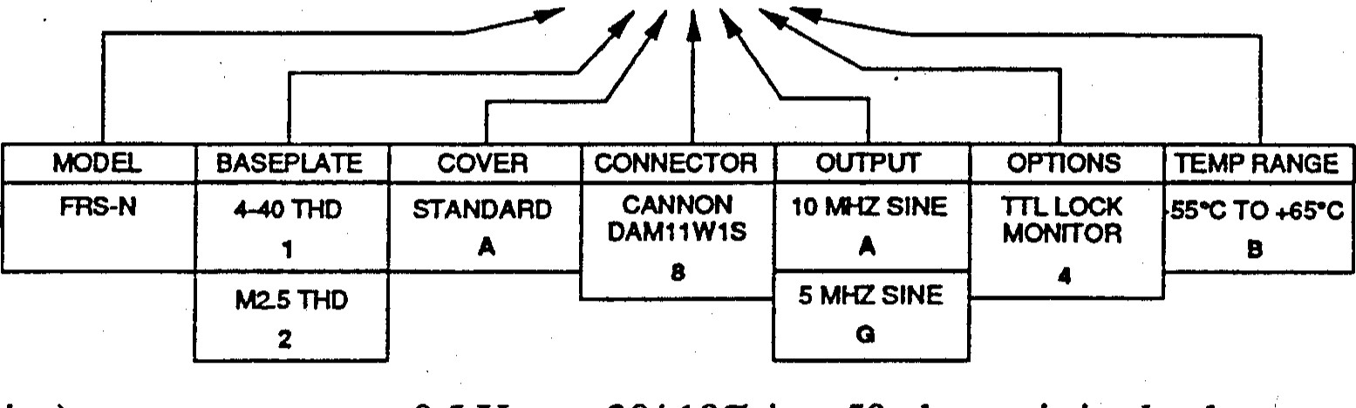

|  |  |  |  |  |  |  |  |  |  |  |  |  |  |  |  |  |  |  |  |  |  |  |  |
| --- | --- | --- | --- | --- | --- | --- | --- | --- | --- | --- | --- | --- | --- | --- | --- | --- | --- | --- | --- | --- | --- | --- | --- |
|  | |  |  | | --- | --- | | Amplitude (Sine): | 0.5 Vrms +30/-10% into 50 ohm resistive load | | Amplitude (TTL): | Low: O to +0.8V, High: +3.5 to +5.5V, into 50 resistive load. | | Accuracy Setting at Shipment: | ±5E-11 (25 0C) (Accuracy after 1 year): IE-9/Year | | Input Voltage Range: | 24 Vdc nominal (22-29.5 Vdc) (RTCA DO-160B, CAT A for voltage levels and spikes) | | Power-steady State: | 12 W @ 24 Vdc at 25 0C Base Plate | | At tum on: | 2.0 A peak | | Steady state: | 21 W @ 24 Vdc (circulated air, Base Plate-450C) | | Input Voltage Sensitivity:  Warm-up Characteristics: | 5E-11 (for Vdc) | | Time to lock @ 25 0C: | 4 minutes | | @ -55 0C | 8 minutes | | Minutes/Freq @ 25 0C: | 6 minutes/1E-9 | |

Long Term Drift: 5E-11/M0*, ±5E-10/Yr I-Day Stability:

Short-Term Stability: (5 & 10 NåHz outputs only)

|  |  |
| --- | --- |
| 1.0 Second (Allan Var.) | 5E-11 |
| 10 Sec. (Allan var.) | 1.58E-11 |
| 100 Sec. (Allan var.) | 5E-12 |
| Phase Noise (SSB 1 Hz BW) : | -70dBcNHz at IHz, -1 IOdBcNhz at IOOHz,  -130 dBcNHz at 1 KHz |

Harmonic/Non-Harmonic Distortion: 10 MHz = -40 dBc/ -65 dBc;  5 = -40 dBc/-60 dB

Frequency Trim Range: ±1E-9 rninirnum

|  |  |
| --- | --- |
| FrequencyRetrace: | SE-11 |
| Setting Resolution: | IE-II |
| Magnetic Field Sensitivity: | 4E-13/A m-' (worst case), (3E-11/gauss), CAT. A |
| Electrical Protection: | Intemal diode/fuse protects against reverse polarity connection. Rf output/BIT short-circuit protected |

ENVIRONMENTAL CONDITIONS (per RTCA DO-160B)



|  |  |
| --- | --- |
| Temperature / Altitude: | CAT. El |
| Operating Temperature: | -5 0C to +65 0C baseplate (5E-lO)  250C + 250C ambient |
| Storage Temperature: | -55 0C to +850C |
| Altitude: | 70,000 ft. (21,300 m) |
| Magnetic Field: | 4E-13/AM•' (3E-11/0.1 mfllitesla) |
| Temperature Variations: | CAT. B, (50C per minute minimum) |
| Humidity: | CAT. A, (95 RH) |
| Shock Operational: | 6 g, Il ms |
| Crash Safety: | 12 g, 11 ms |
| Vibration (sinewave): | cuwes M, N, O  1.5 g to 500 Hz  1.0 g to 1000 Hz |
| Explosion: | CAT. E |
| Waterproofness: | CAT. X |
| Fluids Susceptibility: | CAT. X |
| Sand and Dust: | CAT. X |
| Fungus: | CAT. X |
| Salt Spray: | CAT. X |
| Magnetic Effect: | CAT. A |
| Power Input: | CAT. A for steady state voltage levels and voltage spikes CAT. B for ripple susceptibility |
| Voltage Spike: | CAT. A |
| Audio Frequency Conducted: | CAT. B |

Susceptibility - Power Input:

Induced Signal Susceptibility] CAT. A Radio Frequengy Susceptibilityl CAT. A Emission of Radio Frequency! CAT. A

PHYSICAL CHARACTERISTICS Size (inches, h / w / l): Weight:

Connectors :

Baseplate Threads: Warranty:

* After I month of continuous operation ** Refer to Section 1-6. 

2.0 x 3.0 x 4.0 (5.1 x 7.6 x 10.2 cm) lbs/inches cubed: 1.2 / 24 kg/cm cubed: 0.55 / 395

Mate with Cannon Series DAMI 1 WIS

(STD) 440 (M2.5 option)

12 months

## CHAPTER 2

INSTALLATION AND OPERATION

2.1 INTRODUCTION. This chapter ofthe manual contains information regarding the installation and operation of the Efratom Model FRS. It is recommended that this chapter be read carefully prior to attempting operation of the unit.

2.2 SHIPPING AND RECEIVING INFORMATION. The Model FRS is packaged and shipped in a foam-packed container. The unit is inspected mechanically and elecüically prior to shipment. Upon receipt of the unit, a thorough inspection should be made to ensurethat no damage has occurred during shipping. If any damage is discovered, contact Ball Corp., Efratom Division, 3 Parker, Irvine, CA. 92718. Telephone 714/770-5000; Telex 685-635; FAX 714/770-2463. If reshipment of the unit is necessary, the original container and packing should be used. If the original container is not available, a suitable container with foam-packing is recommended.

2.3 MOUNTING. The unit should be mounted with the thermal baseplate in contact with a flat metal surface (.005 inches rms or better). Mounting screws (4-40) must not be allowed to penetrate the baseplate more than 0.2 inches (5mm). It is recommended that the mounting surface be designed to permit free access to the unit's frequency adjust potentiometer.

The heat transfer characteristics of the mounting surface must be adequate to limit the rise of the unit's baseplate to < +65 0C. The allowable environmental temperature (Ta), for this mounting is:

### = 65 0 C - vs, Is, Rk

Vs = Supply Voltage in volts

Where: Is = Supply Current in amperes

 = Thermal Resistance between unit and  OC/watt).

2.4 POWER REQUIREMENTS. The Model FRS requires an extemal power source capable of providing between +22 and +30 Vdc, with a minimum of 2.5 ampere output. The positive input voltages for the unit is to pins 9 (electronics) and 6 (heater) with the negative retum voltage on pin 10 of the connector.

In order to obtain the cleanest output signal close to the carrier, the maximum ac ripple on the supply voltage must be less than 1 mV peak-to-peak. If non-harmonics at the supply ripple frequency (50, 60, or 400 Hz) are not a consideration, the ripple can be higher, but in no case should the supply voltage AC -F/- peak exceed the upper or lower input power limit of the unit.

2.5 INSTALLATION CONSIDERATIONS. Some consideration must be given to the operating location of the unit, regardless of its application. To minimize frequency offsets and/or non-harmonic distortion, the unit should not be installed near equipment generating strong magnetic fields such as generators, transformers, etc.

CAUTION

Care must be taken to ensure that the maximum operating temperature is not exceeded, (+65 0 C as measured at the unit's baseplate).

2-1

2-6. SIGNAL INPUTS AND OUTPUTS. Figure 2-1, illustrates the Model FRS Cannon connector or pin COnnectlOns.

PIN DESCRIPTION

CoaxRF Out/Shield

1 Lock Monitor

2External Frequency Adjust (wiper of potentiometer)*

3External Frequency Adjust (ground for potentiometer)

4Lamp Monitor*

5Not Used

6 Heater Power +24 Vdc

7Crystal Monitor (crystal control voltage)* 8 External Frequency Adjust (regulator monitor - positive for potentiometer)

Regulated Input Voltage (+24 Vdc) Power Return



10

*Refer to Appendix B

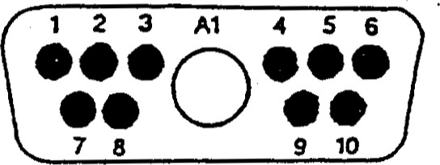

FIGURE 2-1. Cannon connector Jl Pin Arrangement

2-7. NORMAL OPERATION. When 24 Vdc is applied to pins 9 and 6(+) and 10(-), the unit will immediately begin generating a 10 MHz signal from the crystal oscillator. Within approximately 4 to 6 minutes after application of input power, the unit will "lock". The crystal is now stabilized by the atomic resonant frequency.

2-8. FUNCTIONAL OPERATION TEST EQUIPMENT. The equipment required to functionally test the unit is listed in Table 2-1. Test equipment other than those items listed may be used provided that the performance equals or exceeds the MINMUM USE CHARACTERISTICS as stated in Table 2-1.

TABLE 2-1. Functional Operation Test Equipment

|  |  |  |  |
| --- | --- | --- | --- |
| Para. No. | ITEM | MINIMUM USE CHARACTERISTICS | TEST EQUIP. |
| 2.1  2.2  2.3  2.4 | DC Power Supply  DMM (Digital  Multimeter)  Freq. & Time  Interval Analyzer  Optional External Freq. Ref. | Output Voltage: +22 to +30 Vdc  Voltage Range: O to 30 Vdc  -Accuracy ±l .25% - Resistance Range: O to 150 ohm.  Ref. Freq. 10  Resolution: IE-IO  Output Frequency: 10 hÆ-Iz  Accuracy: ±5E-12  Stability: Parts in 10 12, or as req. | Hewlett-Packard 6433B Fluke 8020A or 8000A  Hewlett-Packard 5371 A  Cesium standard |

2-2

2.10 SHORT TERM STABILITY TEST (ALLAN VARIANCE)

NOTE

 If steps 2-9 through 2-9d have been completed, and the Allan Variance indications (as displayed on the HP-5371A) are of the required averaging times, the test results as indicated are valid. If 2-9 was not performed, continue with 2-10.

1. With the equipment connected as shown in Figure 2-2, and the required stabilization time allowed, (refer to NOTE following 2-9b), begin the test.
2. Allow sufficient time for the test set to display the data for the averaging times required, and verify that the UUT Allan Variance is within the tolerance listed in Table 1-1, SPECIFICATIONS.
3. If no other tests are necessary, disconnect the test set-up.

NOTE

Throughout the test procedures in this manual the FRS will be referred to as the UUT (Unit Under Test). In addition, connections described or illustrated pertain to the Cannon connector. 

2.9 OPERATIONAL FREQUENCY ACCURACY TEST.

* + 1. Connect the equipment as shown in Figure 2-2.

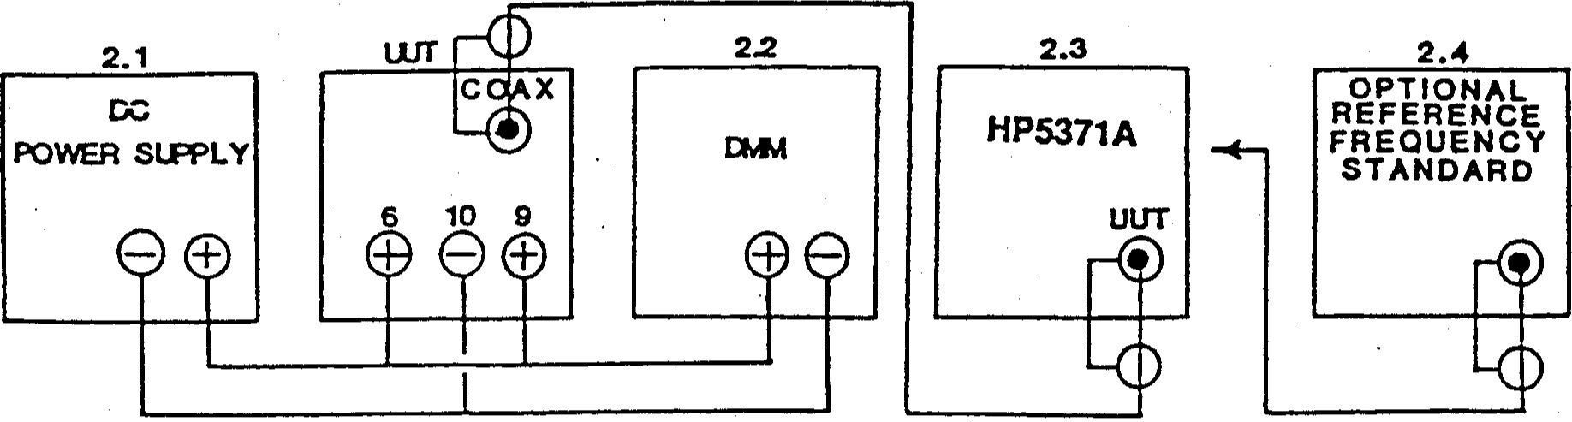

Figure 2-2. Operational Frequency Accuracy Test Setup.

* + 1. Adjust the DC power supply controls to obtain a 24 ± 1.4 Vdc indication on the DNRvf. Allow sufficient time for equipment to stabilize.

NOTE

The UUT requires 4 minutes (@ 25 0C) to stabilize for the following frequency accuracy: ±1E-9 (after 1 yr operation) of the final frequency (calibrated frequency), or the frequency before tum off, (providing turn off was within 24 hours). If the unit has been calibrated recently, the maximum frequency offset after 1 hour operation would be ±2E-11 warrnup accuracy, ±2E-11 retrace. This assumes the last calibration was at the same ambient temperature.

* + 1. Begin the test (refer to Frequency & Time Analyzer or HP537 IA manuals).

1. Allow sufficient time for the test set to indicate the UUT OFFSET for the data you require. Verify that the UUT frequency offset is within the tolerance stated in the NOTE following Step 2-9b.

2-3 

CHAPTER 3 THEORY OF OPERATION

* 1. INTRODUCTION. This chapter of the manual contains a general theory of operation and circuit analysis of the Model FRS Rubidium Standard. Schematic diagrams are included in the Appendix to help clarify the text.
  2. GENERAL THEORY. The FRS generates a stable 10 IVIHz output frequency from a 20 MHz Voltage Controlled Crystal Oscillator (VCXO), whose frequency is locked to the atomic-standard "resonance frequency" of the rubidium atom (rubidium reference frequency). Figures 3-1 and 3-2 show how the standard works.

 A microwave signal that is derived from the VCXO tuneable oscillator is applied  to rubidium vapor contained within a heated glass cell. Light from a rubidium lamp is passed through the cell and illuminates a photo detector causing current to flow in the detector. As the applied microwave signal approaches the frequency that corresponds to the ultrastable rubidium atomic resonance frequency, the rubidium light entering the glass cell is absorbed by the rubidium vapor to an increased extent causing a decrease in the photo detector current. This "darkening" effect is used to generate an error signal which permits continuous regulation of the quartz crystal oscillator output frequency, thereby locking it to the atomicstandard frequency.

 RUBIDIUM REFERENCE FREQUENCY. atomic-standard frequency (fRb) used for reference is provided by the 6.834 GHz ground-state hyperfine transition of 87Rb (rubidium) atoms. The VCXO is locked to this frequency by means of a microwave signal (fc), generated from the 20 MHz VCXO output, having a frequency in the vicinity of fRb. The frequency synthesis and multiplication scheme is designed so that the VCXO frequency is exactly 20 MHz when the microwave frequency (fc) is equal to the rubidium reference frequency, fRb. The microwave signal excites vapor phase 87Rb atoms that are contained in the heated glass cell within the microwave cavity (resonator) (see Figure 3-2).

RUBIDIUM I-ANT. Light from the rubidium lamp is generated by an If-excited plasma discharge. Rubidium in the lamp is heated to a vapor state (approximately 1060C) and subjected to a high-energy rf field. This If field causes a plasma discharge which produces rubidium light of the proper wavelength. 'The light passes through rubidium vapor contained in the resonance cell, where some of the light is attenuated. The remaining light is incident upon a silicon photo detector (photocell) within the resonator cavity. When the applied microwave frequency (fc) is equal to the hyperfine frequency, fRb, the rubidium atoms resonate with the microwave field in the cavity, causing the light reaching the photo detector to decrease. This decrease in light intensity is made possible by the simultaneous interaction of rubidium light and microwave energy, a process called "Optical Pumping". (This behavior is illustrated by the V-shaped curve in Figure 3-3. )

'Ihe darkening effect described above is used to generate the error signal that is processed by the servo (control) circuits to correct the VCXO frequency, maintaining a "locked" condition when the applied microwave frequency (f ) is equal to the hyperfine frequency fRb. Figure 3-1 is a block diagram of this process.

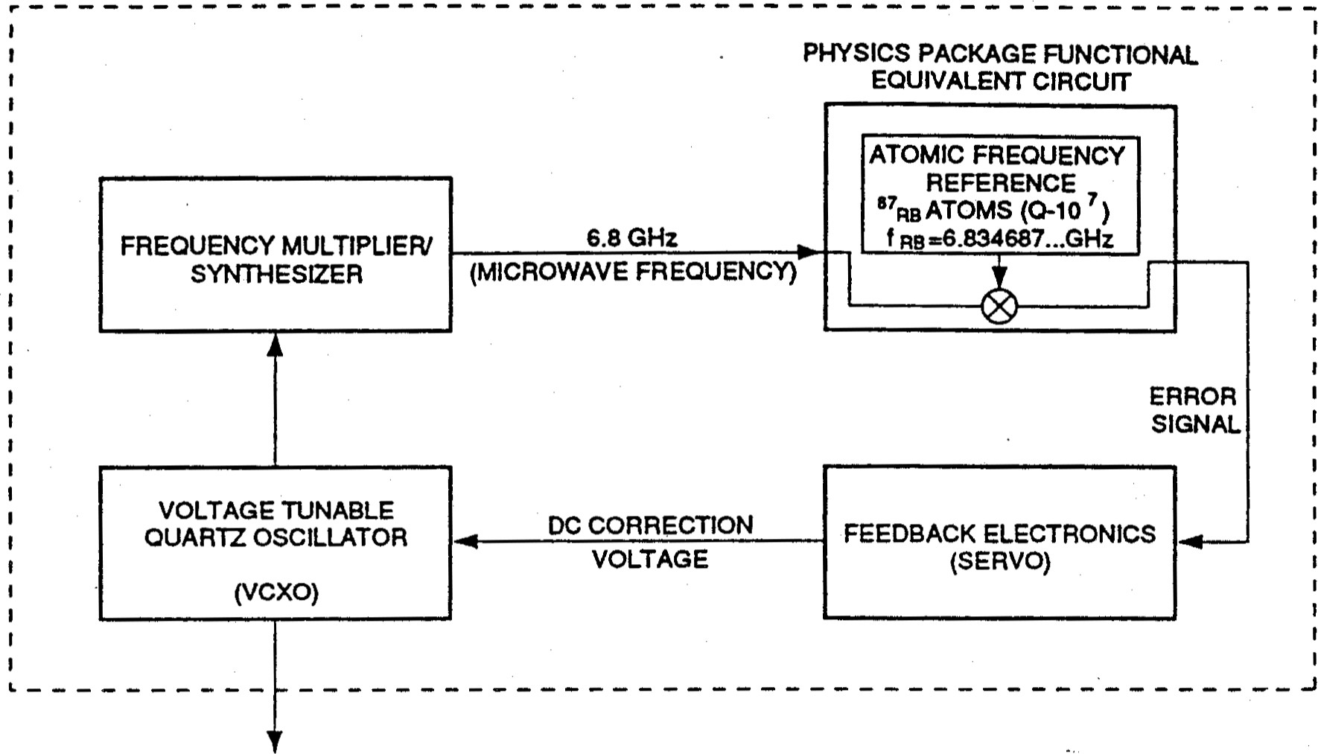

### 10 MHz OUTPUT

Figure 3-1. Simplified Block Diagram of Rubidium Atomic Standard

RUBIDIUM STANDARD PHYSIC PACKAGE

TEMPERATURE-CONTROLLED RUBIDIUM LIGHT

METAL HOUSING

PHOTOCELL

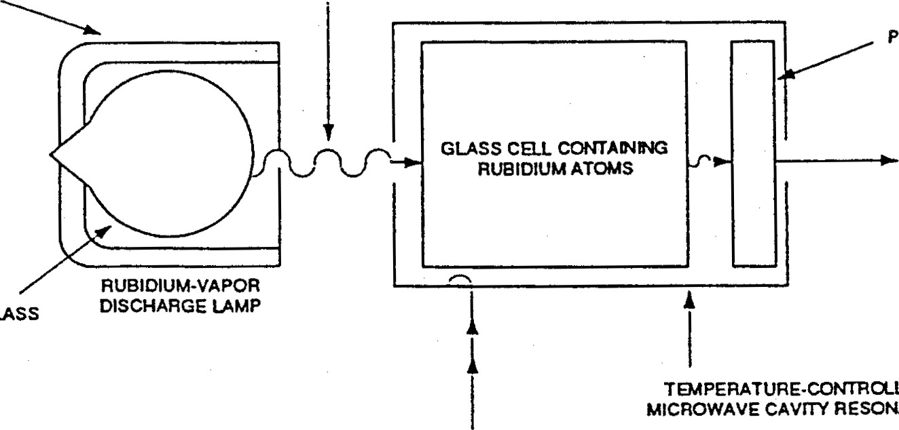

GLASS

TEMPERATURE-CONTRCILED

RESONATOR

ELECTRICAL ERROR SIGNAL go FEEDBACK ELECTRONICS)

MULTIPLIED FREOUO*CY (6.8 GHz)

WHEN MULTTIPLIED FREQUENCY EQUALS THE RUBIDIUM ATOM FREQUENCY. TYE ERROR SIGNAL IS ZERO.

WHEN THE •two FREQUENCIES ARE DIFFERENT. AN ERROR SGML IS GENERATED THAT IS USED TO •STEER' THE VCXO FREQUENCY TO NE CORRECT VALUE-

Figure 3-2. Simplified Block Diagram of Physics Package

### 3-2

OPTICAL  The rubidium oscillator is a passive device in that the atoms themselves do not produce a self-sustaining microwave oscillation. l'he atomic resonance is detected passively by optical means and involves a process by which atoms are raised to a higher energy state through the absorption of light energy.

To understand how the optical darkening effect occurs, it is necessary to understand the atomic physics phenomenon called "Optical Pumping".

According to Planck's theory, when radiation is absorbed or ernitted by an atom, the energy is absorbed or emitted in whole packets, or quanta, called photons. Atoms therefore exist only at specific energy levels.

For rubidium the lowest two energy levels are called the ground-state hyperfine levels and are denoted by A and B in Figure 3-4. 'Ihe rubidium atoms will ordinarily be equally divided between these two levels (Figure 3-4-1). If the atoms are i.rradiated with microwave energy at the hyperfine frequency, then the atoms at level A will make a transition to level B and vice-versa, without changing the overall distribution between the two levels (Figure 34-11). Pl'his transition takes place at the hyperfine frequency of rubidium, (fRb). The hyperfine frequency is related to the hyperfine energy level separation by a fundamental equation of physics:

ERb (joules) = h fRb, where h = Plank's Constant = 6.626 E-34 joules/Hz.

A third and much higher energy state, level C, also exists which is normally vacant. Level C is excited by infrared light energy of the proper wavelength from the rubidium lamp (Figure 3-4-111). Transitions to level C are known as "optical transitions" and can occur from either of the two hyperfine energy levels A or B. After a short time (—25 nsec), the atoms which were raised to the C level will emit a photon of approximately the same wavelength as the  original photon. They then retum to the ground state hyperfine level, redistributing themselves approximately equally between levels A and B (Figure 3-4-IV).

If the spectral wavelength corresponding to only one of the hyperfine levels is introduced, level A for example, only the atoms at that hyperfine level will make the transition to level C (Figure 34-V). This condition is generated by filtering out the spectral wavelength corresponding to the other hyperfine level, B. In rubidium oscillators manufactured by EFRATOM, an isotope of rubidium 85Rb, mixed with the 87Rb in the resonance cell, perfonns the filtering function.

As the filtered light energy passes through the resonance cell, level A to C transitions occur so that the rubidium atoms excited to the C level emit photons and retum to the ground state redistributing themselves equally between levels A and B (Figure 3-4-VI). 'Ihe atoms which return to level A will again absorb light and be raised to level C, where they will remain for a short time before emitting a photon and again redistributing themselves between the two levels A and B. As this process continues, eventually there will be no atoms left at level A to be excited to level C (Figure 3-4-VII). The atoms will stay at level B because the filtered iight is not the proper waveiength to excite them to level C. -By this process ail of the atoms are pumped to hyperfine level B, producing a population difference between the two hyperfine levels, A and B.

Once all the atoms are pumped to level B, and in the absence of the corect microwave energy, light is no longer absorbed and passes unattenuated through the resonance cell.

When a microwave field with frequency corresponding to the hyperfine frequency is applied, the atoms at level B make the transition to level A and vice-versa. However, due to optical pumping, when the atoms from level B make the transition to level A they are also available for excitation to level C by the light beam. Since each excitation of an atom at level A is accompanied by the absorption of a light photon, the net effect of applying the microwave field at the hyperfine frequency is to cause continued attenuation of the light bearn. (It should be mentioned that when Rb atoms absorb photons and subsequently make C A or C B transitions, the re-emitted photons are emitted with equal probability in all directions so that most of these photons never reach the photo detector. Thus, a photon originally removed from the light beam is replaced by a photon that, in most cases, is not detected.) Figure 3-4 illusffates the Optical Pumping process.

ELECTRONIC ANALOGUE. The operating behavior of the physics package can be viewed in its sirnplest form as a high-Q series-resonant tank circuit that is resonant at the hyperfine frequency (6.8 GHz). (See Figure 3-5.) The voltage source driving the tank is the microwave frequency (fc) derived from the 20 MHz VCXO, and the LCR components are the rubidium atoms contained in the optical package. Figure 3-5 includes the effects of modulation, which are described below.

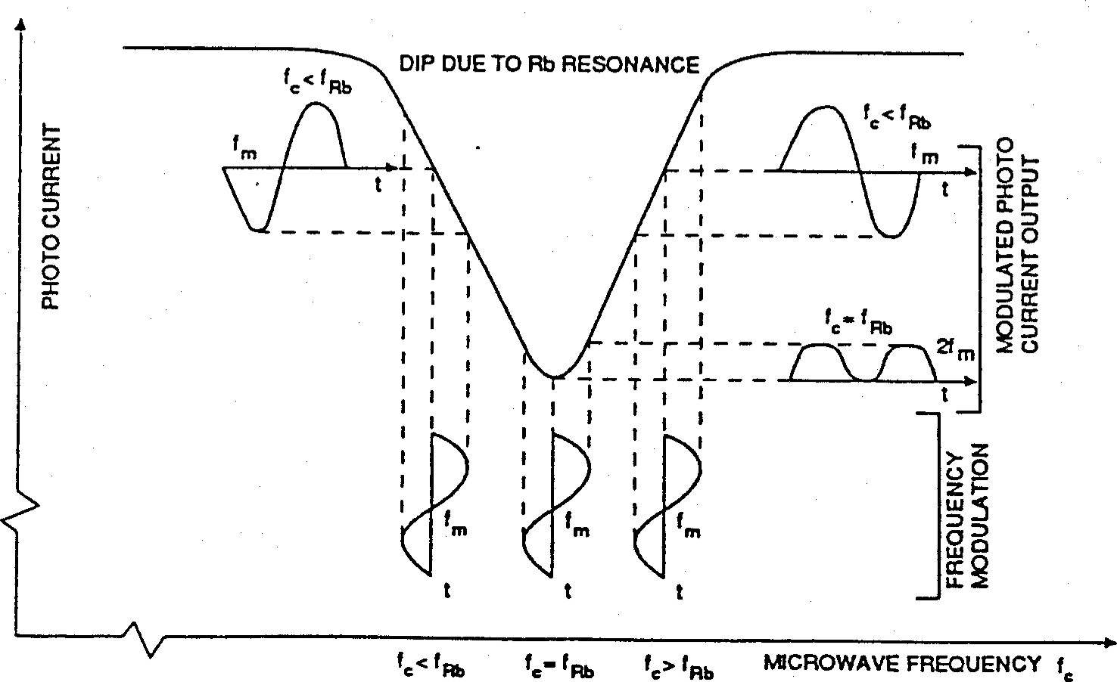

Figure 3-3. Derivation of Modulation Signal

FREQUENCY MODULATION. Because of the small changes in detected light intensity €0.1%) that are associated with locking the VCXO to the rubidium reference frequency, an ac detection scheme is used. The advantage of an ac detection scheme compared to a dc

FRS

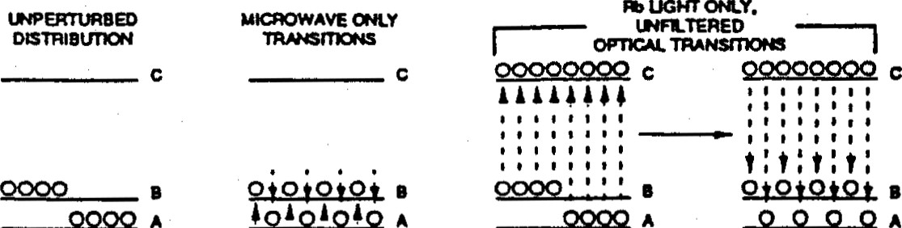

1. a e EOUA- A TO B. n e TOC -UGHT earrr@
2. TOA .UGHT ABSORBED C TOA" Ea.WXY v:

A pu.4PED TO B

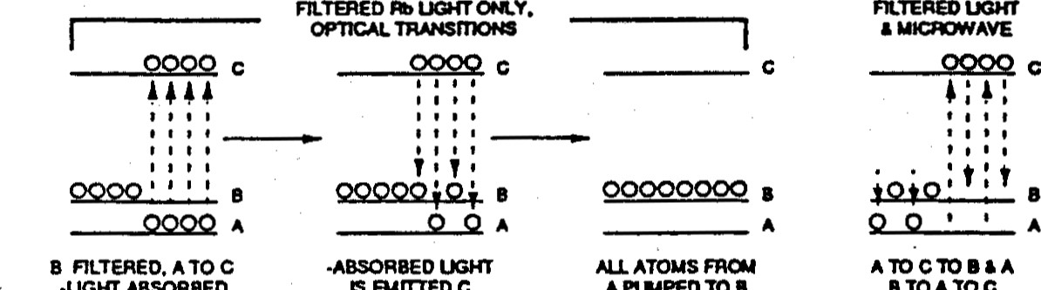

.UGKT

ABSORBED

s

ærrrED

c

TO

A

a

B

EOUALLY

STOATOC

A

UGHT

ABSORBED

(A NO LOGE.R

ABSORBEm COM

ACTUAL OPERATON ts SH(NN N FRAME vm IS A STEADY-STATE notESS. STAATNG FROU FRANE W. WHEREBY THE CONTNVOUSLY:

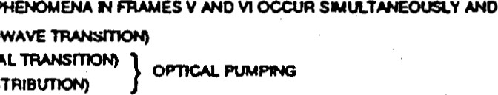B TO A o.ocnow»æ

1. A TO C (OP•nCAL TRANSrnoe.O
2. C TO B (REDISTRIBtmoeo
3. DETECTION OF MICROWAVE TRANSITION BY ccwnqoous OGKT AGORPT'ON DUANG opnc.u PtNPNG

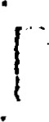Figure 34. Optical Pumping Process.

PHYSICS PACKAGE ELECTRONIC ANALOGUE

SS*'ES mc cna.JiT

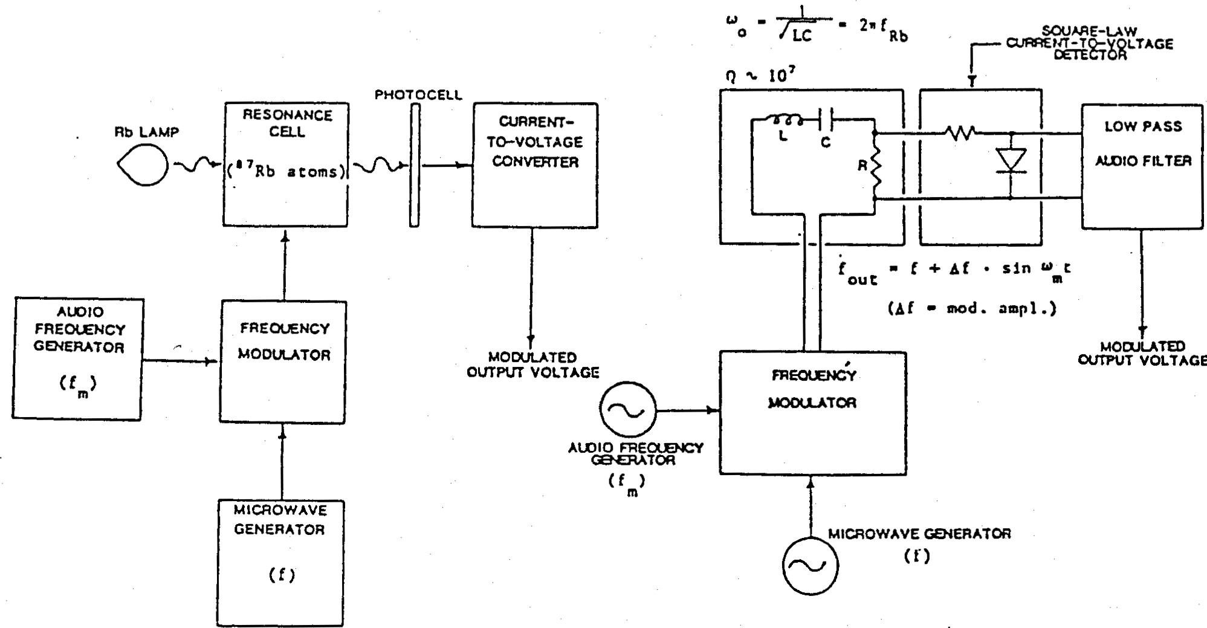

Figure 3-5. Electrical Analogue of Physics Package.

FRS

ueteeüüirsehemeis-ihai.=mail signal changes are not obscured by dc drifts. in order to generate the ac error signal for VCXO frequency correction, the microwave signal is frequency modulated. As the modulated microwave frequency approaches the hyperfine frequency, the light from the rubidium lamp varies in intensity at the modulation rate. 'Ihe variation in the light intensity is very small, only about 0.1% of the overall intensity of the light. The photocell within the cavity detects the small variation in light intensity and a preamp circuit on the resonator board amplifies the signal and sends it to the servo circuits.

RESONANT SIGNAL. By modulating the microwave signal injected into the resonator at 127 Hz, the light striking the photocell, and therefore the output current, varies at 127 Hz as the microwave frequency approaches the hyperfine frequency (Figure 3-2). The servo circuits use this signal to generate a continuous correction signal for the VCXO.

When the microwave frequency (fe) in the resonator is exactly equal to the hyperfine frequency (fRb), the 127 Hz modulation varies the microwave signal around the center of the absorption curve, resulting in a modulation of the photocell current at twice the modulation frequency, or 254 Hz (Figure 3-3). It is this 254 Hz signal which is used to generate the lock indicator signal. The lock indicator signal is the primary indicator that the unit is operating normally. If the microwave signal, fc, which is synthesized from the 20 MHz VCXO, drifts off the hyperfine frequency, fRb the photocell output reverts to the fundamental 127 Hz rate. phase of the 127 Hz indicates if fe is above or below fRb and this phase information is used to move the VCXO frequency in the proper direction until fc again equals f

3.3 DETAILED CIRCUIT DESCRIPTIONS. Figure 3-6 (and the diagram in Appendix A) illustrate the interconnections of the flex board, physics package and the associated circuitry and circuit board assemblies that comprise the rubidium frequency standard.

The two assemblies of the FRS are the PHYSICS PACKAGE assembly and the FLEX

BOARD assembly. The Flex Board interconnects four printed circuit boards (PCBs): the SERVO BOARD, the CRYSTAL OSCILLATOR BOARD, the MULTIPLIER BOARD and the POWER SUPPLY BOARD (refer to the interconnect wiring diagram in the Appendix).

3.3.1 THE PHYSICS PACKAGE. The function ofthe Physics Package is to provide the standard frequency reference and the error signal. The error signal is processed by the servo board to stabilize the frequency of the crystal oscillator.

The Physics Package has two main sub-assemblies: the LAMP ASSElvBLY and the RESONATOR ASSEMBLY. The entire physics package is enclosed in a mu-metal container to shield the resonant cell from magnetic fields.

THE LAMP ASSENBLY (A2 & A7). function of the Lamp Assembly is to generate rubidium light that contains the desired spectral lines of Rb necessary for the process of interrogating the atomic standard frequency. The larnp circuits ignite the Rb lamp and thermostatically control the lamp housing temperature at approximately 1060 C (2230 F), which is required to maintain the proper Rb vapor pressure in the lamp envelope.

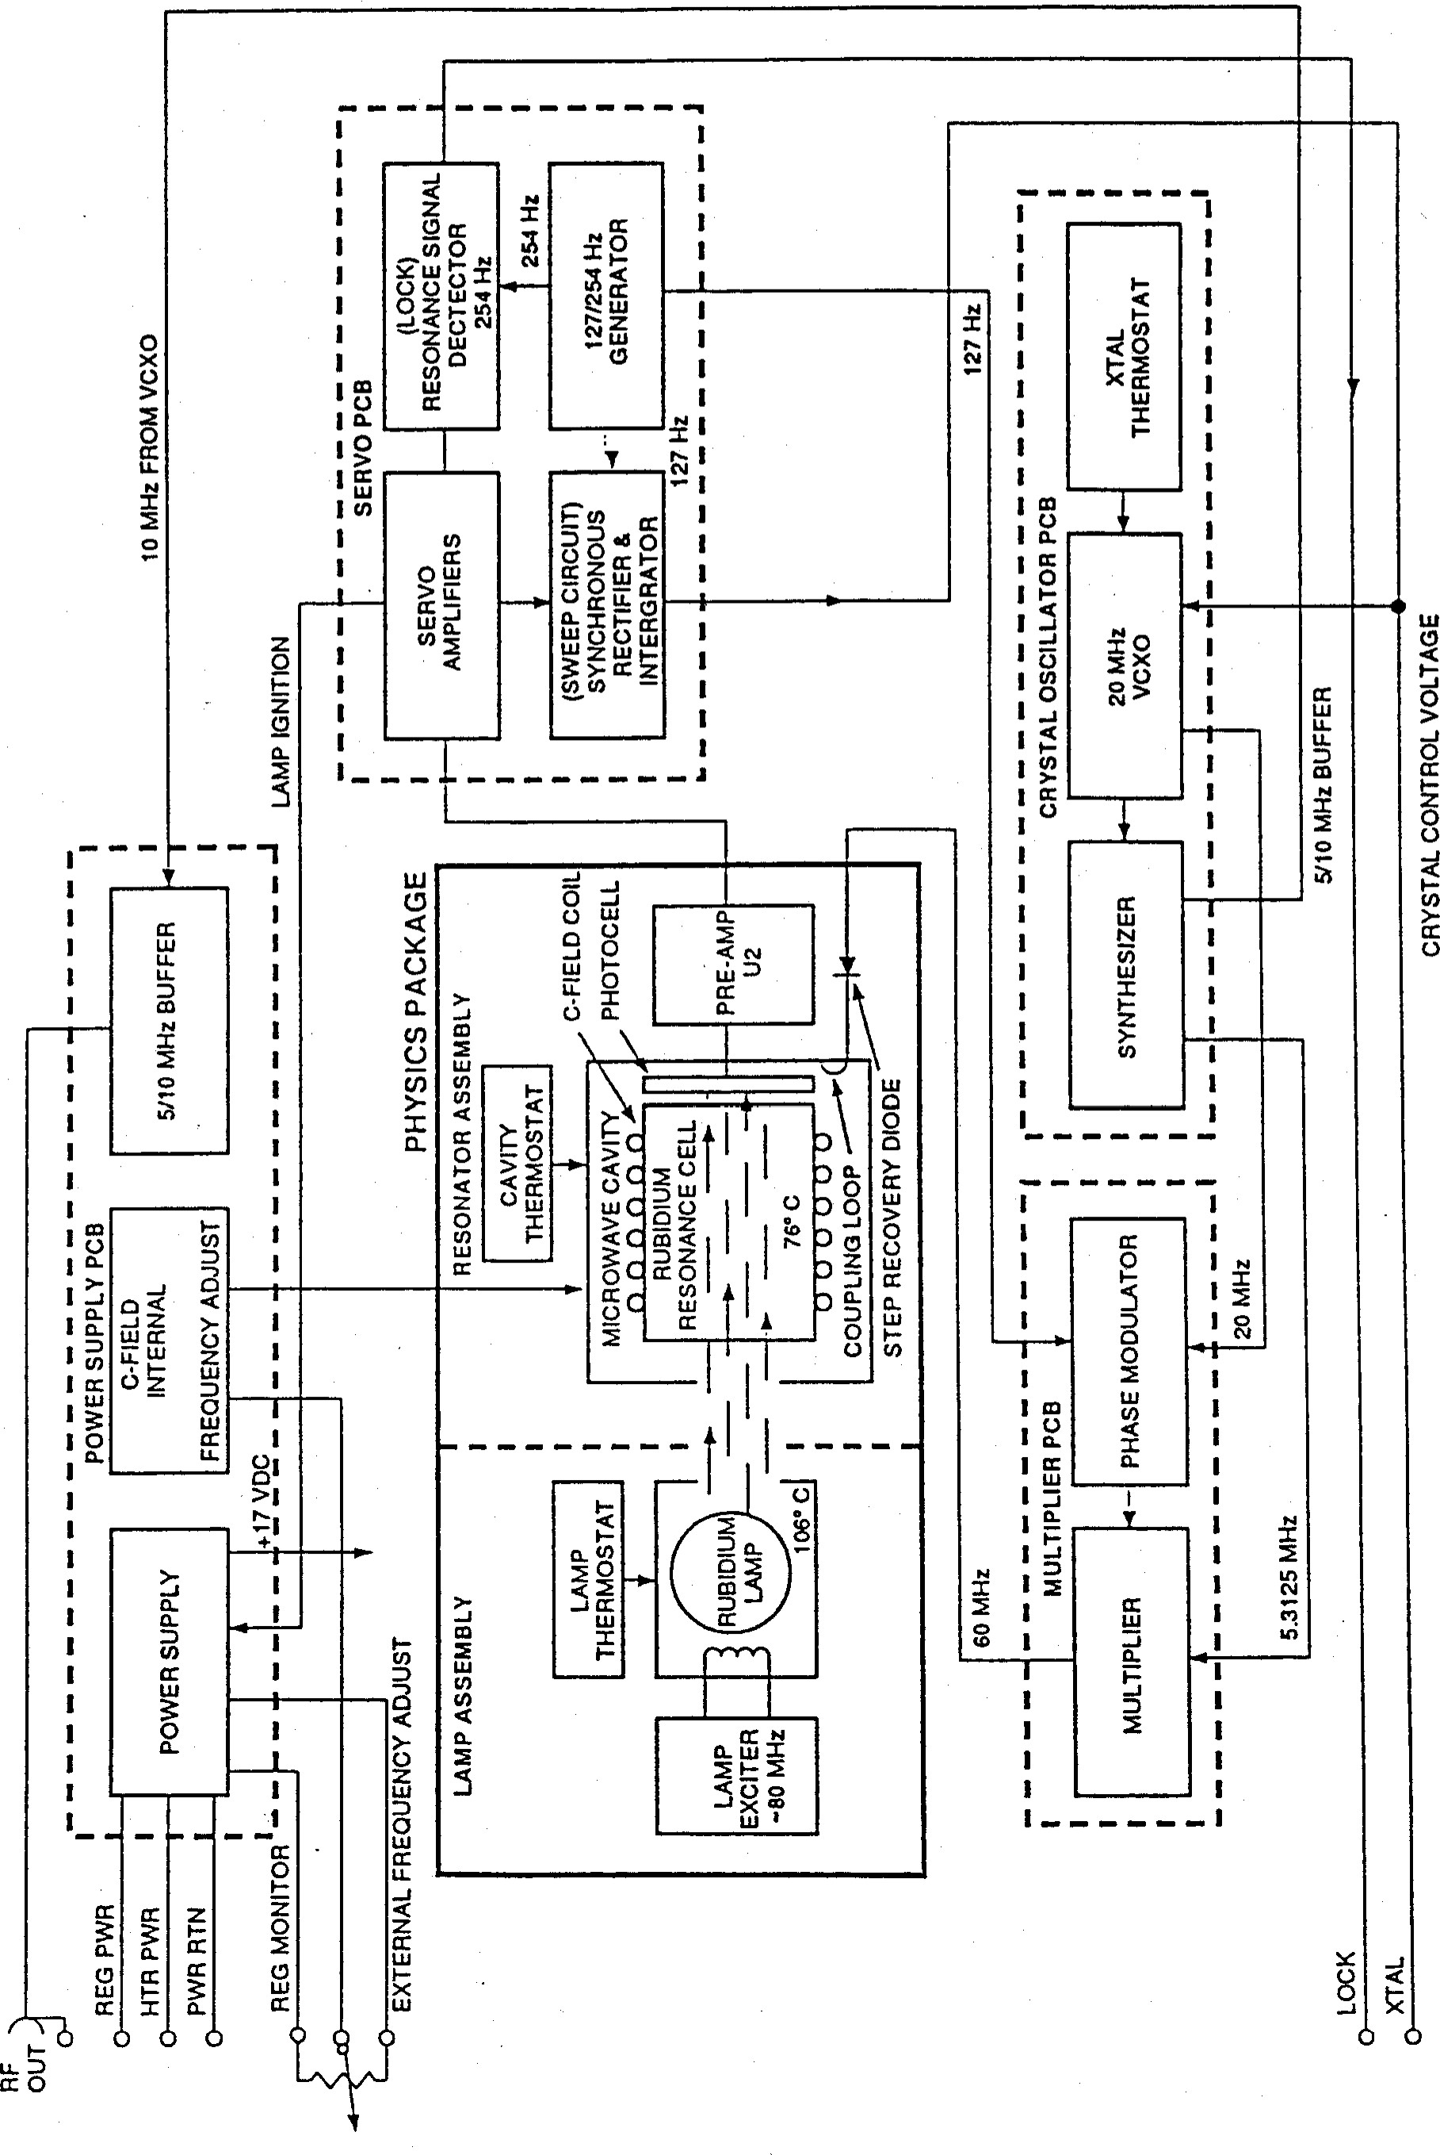

Figure 3-6. Detailed Block Diagram, FRS.

1. 'Ihe Rb lamp oscillator circuit on the A2 and A7 boards is an adjustable 70 to 100 MHz modified Colpitts oscillator and rf transistor Q3 is the active element. CRI provides temperature compensation for the ac biasing of Q3. RIO and RI 1 set the oscillator bias and R12 provides dc bias stabilization. Cll is adjusted to tune the circuit to the desired output frequency, while C7, C8 and C9 are rfbias caps. L5 is a frequency determining element. The remaining passive elements provide If filtering  for the power input.

The larnp oscillator ignites and maintains an electrode-less plasma gas discharge in the rubidium lamp that is mounted in the oscillator's tank circuit, Cll and L6. L6 is a step-up auto-transformer that provides a high voltage for rapid lamp ignition at turn-on.

1. 'Ihe Rb lamp is mounted in a temperature-controlled housing. QI is mounted on the housing and acts as the heating element. Thermistor RTI is the temperature sensor embedded in the housing and with RI forms one side of a bridge circuit. R2 and R3 form the other side. UI is the m•vlifier that senses the bridge balance and controls the heater QI accordingly. Q2 senses the voltdrop across R9 and limits QI current flow by reducing base current. RI selects the desired operating temperature. see section d. RESONATOR HEATER CIRCUIT below for a more detailed analysis of heater controller operation.

THE RESONATOR ASSE1vBLY (A6). Resonator assembly consists of the Resonator board and the Resonator cavity. The cavity is constructed of mu-metal and contains the resonant cell and C-field coil. A heater ring surrounds the cavity and provides its mounting. The lid assembly on the cavity contains the photocell, step recovery diode, and a feedthrough capacitor. Cavity temperature of about 740 C is maintained by the resonator heater control circuit. (See Figure 3-4).

1. THE PHOTOCELL PREARvæ. The resonant signal is detected by the photocell CR2 which provides a variable current signal to the preamplifier U2 on the Resonator board. "Ihe signal is routed through the "flex" board to the Servo circuits that use this signal to correct the VCXO. This ''larnp volts" signal also controls the power supply voltage.
2. STEP RECOVERY DIODE (CRI - refer to Multiplier [A5] schematic) . The step recovery diode is a varactor (voltage variable capacitance) diode designed for frequency multiplication. When the diode is forward-biased and is switched to reverse bias, most of the stored charge is released as a high pulse of reverse current, producing a steep waveform rich in harmonics.

A 60 MHz signal from the multiplier and a 5.3125 hY'1Hz signal from the VCXO are mixed on the multiplier board and then are applied to CRI within the cavity. When CRI conducts, it produces the harnonics of the 60 MHz and 5.3125 MHz mixed signals. 'Ihe resonator cavity and loop are tuned to select the 114th harmonic which corresponds to the resonant frequency of the rubidium.

1. RESONATOR COL (A6). 'Ihe resonator "mag field"coil is wound on the rubidium cell and provides a magnetic field (the C-field) within the resonator cavity. "I"his magnetic field functions as a fine tuning mechanism by changing the hyperfine transition frequency through what is called the "Zeeman effect"; the splitting of a spectrum line of light into several symmetrical components, which occurs when the source of light is placed in a static magnetic field. The "C-field" strength is determined by the current through the coil. The current is summed from the following sources:

NED: R 13 on the Power Supply board (A3) supplies current directly to the coil.

MANUALLY-CONTROLLED: R14 on the Power supply board supplies an adjust able voltage which is fed to UI and R20 on the Resonator board. Extemal (remote) frequency adjustment is possible by applying a 0 to 5 Vdc voltage source to PI, pin

2. (See the Power Supply schematic in the Appendix).

CONQENSATION: 'Ihe Resonator heater (A6 assembly) current varies inversely with the ambient temperature. This condition is used to provide compensation for frequency shifts that occur due to ambient temperature changes. 'Ihe voltdrop across R 19 in the resonator heater circuit is used to detect the changes and is processed thru UI and R27, or thru R 12, into a temperature variable current. This current adjusts the magnetic field to compensate for the ambient temperature changes. The current is passed thru Power Supply board select-in-test resistor A3 R 12 for accessibility to change the current magnitude as necessary. Positive compensation is achieved through UI and R27 and negative compensation is achieved through R 12.

1. RESONATOR HEATER CIRCUIT (A6). The operation of the resonator heater and its control circuits is typical of the other heater circuits in the unit. The heating elements are QI and Q2 which are mounted on the heater ring that surrounds the resonator cavity. The temperature sensing element, thermistor A6 R21, is embedded in the heater ring. Its resistance drops from about 10K Ohms at room temperature to less than 1K Ohm at 740C. 'Ihe remaining circuitry is mounted on the Resonator and Power Supply circuit boards.

UI is an Op Amp with a resistive bridge network on its inputs. On one side of the bridge are fixed resistors R2 and R3. On the other side of the bridge are the thermistor R21, resistor R22 and select-in-test resistor A3 R 15 on the Power Supply board, which adjusts the temperature of the Resonator.

When power is tumed on the bridge is unbalanced causing the Op Amp UI output to turn Q2 on full. This causes the voltage at the collector of Q2 to drop, turning QI on full. Q3 functions as a current limiter for the heater circuit. 'Ihe current thru QI and Q2 passes thru RI 9 causing a voltdrop. When the voltdrop exceeds the Q3 base to junction voltage, Q3 tums on. Some of the current from the Op Amp is now diverted thru the Q3 collector to ground instead of thru the base of Q2, thus limiting the QI and Q2 current flow.

By selecting the resistance vaiue of A3 R 15, xhe up timp wiii drive the resonatorheaters-iifriihne desired temperature is attained. At this point, the voltage at the R21 and R22 junction will equal the voltage at the R2 and R3 junction and the bridge will be balanced.

With the bridge balanced, the circuit regulates the power to the heater transistors, thereby maintaining the resonator at the temperature selected by A3 RI 5. In order to control temperature overshoot, a portion of UI, pin 1 output is fed back to the input. This slows down the rate of change sensed at the input during rapid transitions by reducing the UI pin 2-3 difference. UI pin 6 senses the current through the heater by detecting the voltage drop across R 19 for temperature compensation as outlined in c. above. The R7, R8 divider limits the heater current when higher input voltages are present to keep the maximum heater power relatively constant.

3.3.2 SERVO BOARD ASSEVIBLY (Al). The primary function of the servo circuits is to process the error signal received from the resonator preamp at Jl pin 3 to provide the crystal control voltage for the 20 VCXO at Jl pin 4. The control voltage is derived by comparing the phase of the 127 Hz modulation signal with the phase of the photocell signal at Jl pin 3. The secondary function is to provide the atornic resonance lock signal at Jl pin 8.

a) 127 AND 254 Hz REFERENCE SIGNALS. The CMOS oscillator/divider U4 on the servo board provides the 127 and 254 Hz reference signals. The oscillator frequency of 8.128 Khz is determined by C22, R 13 and select-in-test resistor R 12. The divider portion of U4 divides the oscillator frequency into the required 127 and 254 Hz signals. The 127 Hz reference signal is routed from U4 pin 4 to pin 9 of synchronous demodulator U3; and to the  input of U2, pin 2 through the RC network R36, C38. The RC network R36, C38 in addition to the feedback network R37, C37 and the output RC filters (R41, R42, and C41 on the servo board; R8, C7, and C8 on the synthesizer board) serve to waveshape the 127 Hz signal into the sinewave which is coupled to the synthesizer to modulate the rf.

The 254 Hz reference signal is routed from U4 pin 5 to pin 10 of synchronous demodulator U3. 'Ihe 254 and 127 Hz reference signals control the timing of analog switches in the synchronous demodulator.

1. MODULATION ERROR SIGNAL. modulation error signal received at the photocell is preamplified on the resonator board (see Figures 3-2 and 3-7) and received at the servo (Al) input Jl , pin 3. The signal is then routed through three capacitively coupled amplifier stages (UI in pin 13, out pin 14; UI in pin 9, out pin 8). The resultant signal is then routed to U3, pin 3 and also UI, pin 6 where it is further amplified and output from pin 7 to U3, pin 2.
2. SYNCHRONOUS DEMODULATION. The amplified modulation signal received at U3, pin 3 is subsequently demodulated at a 127 Hz rate. See Figure 3-3, f . The resulting demodulated output (U3, pin 4) can be observed at TPI on the flex board. See Figure 3-7. 'Ihe TPI output signal is the result of synchronous demodulation and contains both phase and mvlitude  indicating whether above, below or "on" the rubidium frequency. The further amplified signal received at U3, pin 2 is demodulated at a 254 Hz rate. See

Figure 3-2, 2f . The resulting output (U3, pin 15) is a positive 1/2 cycle of the 254 Hz, 2f

signal received when "on frequency" during normal operation. This "lock" signal is used as input to the second harmonic lock circuit.

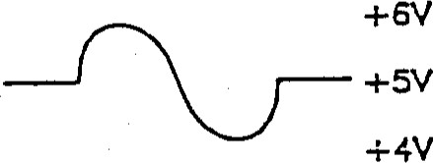 REF 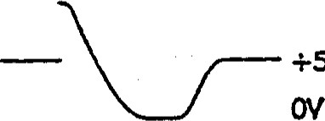+5,' REF

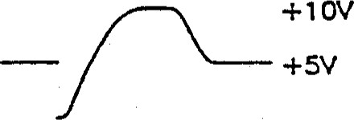

REF

1) VCXO ON CENTER FREQUENC( 2) VCXO LOW 3) VCXO HIGH

FIGURE 3-7. TPI Phase and Amplitude Indications.

1. mTEGRATOR U5. U5 Functions as an integrator whose output voltage fluctuates at a rate proportional to the input voltage. As an example, an input differential of 1000 mV causes an output voltage change of 500 MV per second. The changes will continue until the differential input is nullified by bringing the crystal back to center frequency, or until the Op Amp reaches its maxirnum or minimum output voltage. The output of integrator U5 is the crystal control voltage used to control the frequency of the VCXO via a varactor diode (crystal oscillator CRI). A portion of the integrator output is also routed to the sweep control circuit at UI, pin 3.
2. SWEEP CONTROL CIRCUIT. UI, pins 1, 2, and 3 is a high hysteresis switch and controls the sweep range. Its output is either low (about 0.5 Vdc) or high (about 10.5 Vdc). When no "lock" signal is present (+10 Vdc on U3, pin 11), the output of UI, pin 1 is routed to the integrator input (U3 pin 14) via U3, pin 13. Diode CR2 clamps the UI output to the 5 Vdc reference voltage resulting in a slow down sweep of the crystal control voltage of about  250 mV per second. When the output of UI goes low, the differential voltage on the integrator is about 5 Vdc, resulting in an up sweep of about 2.5 V/sec. The hysteresis of UI pins 1, 2 and 3 is set by R23, R24 and the reference voltage on pin 2. The switch changes state  when the voltage on pin 3 goes higher or lower than the reference voltage on pin 2. 'Ihe upper threshold is set at about 12 Vdc crystal control voltage, the lower at about I Vdc.

When the crystal volts signal reaches approxirnately 12 volts, UI, pin 1 is driven high (+10.5 V). This voltage however, is limited by the R25, CR2 clamping circuit to approximately 5.5 volts. The integrator will sense about 500 mV differential and sweep down at about 250 mV/sec. When it reaches below the 1 volt low switch level of UI, the UI output switches low and the crystal control voltage will sweep up at about 2.5 V/sec completing the cycle. Sweeping continues until "Lock" occurs. (U3, pin Il becomes low).

1. LOCK CIRCUITS. The lock circuit uses the positive 1/2 cycle (254 Hz) lock loop signal by integrating it through R 29, C32 to a DC level. If the second harmonic is of significant amplitude (approximately 200 mv peak-to-peak), U6, pin 7 will drive low.

This low signal discharges C30 thru-R28 to produce a-low atÜ3, pin =Lock" then disables the sweep circuit by disconnecting U3, pins 13 and 14 and connecting U3 pins 12 and

This switching places the integrator under fundamental loop control.

A long range (1 Hz) capture circuit functions in much the same way as the lock circuit. When the integrator is in a down sweep, the first detection of atomic resonance will be a very high positive 1/2 cycle VCXO signal. This TPI signal is integrated by R27, C31 to a DC level. If the fundamental is of sufficient amplitude (approximately 200 mV peak-topeak), U6, pin 1 will drive low and the lock will function as explained in the preceding paragraph.

'Ihe lock (output U2, pin 7) is designed to allow jumpers for selection of "high" or "low" lock output signals at Jl pin 8. 'I"his signal is then routed thru the buffer stage of the power supply to the extemal connector.

3.3.3 CRYSTAL OSCILLATOR (A4) (VCXO). The main elements of the VCXO are the crystal Y 1, the oscillator IC UI and the varactor diode CRI. The board also contains a therrnostat circuit and a frequency divider/synthesizer. The 20 MHz AT Cut 3rd overtone crystal is temperature controlled by the thermostat circuit. Q3 functions as the heater element, RTl as the temperature sensor, Q4 as the gain element. Q2 limits the maximum heater current during tum on.

'Ihe 20 MHz signal from the oscillator IC UI is buffered by QI and converted from a 'ITL compatible signal to a sine wave. ms signal drives the multiplier.

The complimentary 20 MHz signal from UI (HC 320) is fed to the divider IC U2. A 5 or 10 MHz signal from U2 (HCT 393) is selected and fed to the output buffer located at the power supply PCB. The standard configuration of the oscillator PCB is for a 10 MHz output. In this case, no jumpers (JPI, 2 and 3) are needed.

For the 10 MHz sine output signal, L4 and C17 suppress sub-harmonics generated by the divider IC.

The 5 IvfHz and 312.5 KHz signals from the divider are added by an "exclusive OR" gate, U3 (HC 86), to provide the 5.3125 MHz synthesis signal for the multiplier output. To provide maximum isolation between the oscillator and the synthesizer IC's, two separate 5 volt regulators VRI and VR2 are used.

3.3.4 MI-JLTm,IER (A5). The multiplier utilizes the 20 Ivmz sinewave signal from the VCXO to generate a 60 signal for the resonator. The 5.3125 MHz signal is summed into the final stage. These summed signals are routed to a step recovery diode in the resonator where they are in turn mixed and multiplied to the 6.834 MHz signal (f ). A tripler consisting of QI and Q2 multiplies the 20 MHz signal to a 60 MHz signal. QI wave shapes the 20 MHz sinewave into a specific positive pulse. ftese pulses are amplified by Q2 to ring the tuned (60 MHz) collector tank. The DC voltage at the Q2 emitter provides DC bias for QI and maintains constant amplitude.

A second stage (CRI, Tl and associated circuiuy) forms a modulator for the 127 Hz modulation signal from the servo. This sinewave signal is routed to CRI (a varicap diode). This diode capacitance varies at the fundarnental 127 Hz rate and forrns a tuned tank with the primary of T 1. The tank reactance then phase modulates the 60 IvfHz which is üxen coupled to the driver stages. The 60 b,/Nz drivers consist of w,'o (Q4 and Q5) capacitively coupled amplifier stages, tuned to 60 MHz. 'Ihe output stage tank (Q5), is a step-down impedance matching transformer tuned to 60 MHz.

5.3125 N'fHz signal synthesized from the crystal board is received through R28 and C21 into the L6, C22 tank which is tuned to 5.3125 1','ß-Iz. The resulting sinewave signal is then coupled through C23 and L7 and summed into the 60 output of the multiplier.

MI-JLTTLIER AGC. The step recovery diode produces a dc bias voltage through rectification of the If across its terminals in the process of generating harrnonics. This dc bias voltage is adjusted by R30, which helps to tune the diode circuit to produce the optimum resonance in the resonator cavity. The step recovery voltage across R30 is monitored by UI and compared to the reference voltage set by R25, R27 and the pot R24 for automatic gain control (AGC) of the Q4 stage. The output of UI changes the bias of Q4 to keep the step recovery voltage constant. The initial setting of the multiplier is done with the AGC inoperative by installing jumper 'I? I to 'I?2 and by turning R24 fully counter clockwise.

3.3.5 POWER SUPPLY. An intemal power supply provides the unregulated, filtered voltages for the Rb lamp heaters, oscillator heater and resonator heaters; in addition to providing the filtered and regulated voltage for unit operation. Ihe power supply board also houses the RF output buffer and the lock indicator buffer. The input voltage line is fuse and diode protected against reverse polarity inputs.

1. +17 VDC REGULATED POWER SUPPLY. +17 Vdc power supply consists of QI, Q2 and UI along with the components in their respective circuitry mounted on the power supply board. Pass transistor QI is heat sinked to the baseplate. Refer to drawing No. 814-144 for a pictorial view of pass transistor QI.
2. POWER SUPPLY OPERATION. After power is initially applied, QI receives sufficient voltage from Q2 (FET) to go to forward bias. Its output then rises toward the input supply and supplies power to UI. CR5 is reversed biased as the +17V line increases, until it achieves zener operation. Ihe +17 V forces UI, pin 7 high and is applied to Q2 which increases voltage to QI. As +17V is approached, CR5 regulates to a 6.4V reference and R5, E, R6 divider senses any input error for regulation. R6 sets the regulated voltage.
3. swrrcHNG CIRCUIT. power supply board accepts the +22 to +32 Vdc input voltage at PI pin 9, and provides +22 Vdc until the Rb lamp lights, at which time the power supply is switched to +17 Vdc. The switching occurs when UI , pin 3 receives a lamp voltage (PI pin 9) exceeding the 6.4 V reference on pin 2. fte output of UI, pin I is high if lamp ignition is normal. The positive voltage reverse biases CR5, and this effectively removes R7 from the circuit. This sets the condition for the power supply output to be lowered to the +17 Vdc required for the intemal circuits of the unit by the R5, R6 voltage

divider. Improper lamp ignition grounds CR4 which in tum places R7 parallel to R6. R7 now selects +22V as the regulator output,

1. RF OUTPUT BUFFER. The Q3 circuit is an RF output buffer designed to accept 5



or 10 MHz TIL inputs. Tabulated values are selected for sine output or TIL square wave output. The RF output signal is referenced to chassis ground.

1. LOCK SIGNAL B UFFQ The Q4 circuit buffers the lock signal from the servo board lock mvlifier output at Al, U2, pin 7 and provides a 'ITL output high or low to the extemal connector PI, pin l. 'Ihe output is high or low when the unit is locked depending on the jumper selection at the servo board Al, U2, inputs 6 and 7.
2. C-FIELD TUNNG. The power supply PCB contains select resistor R 13 that sets the

C-Field bias current. This current is fixed and should only be changed if the physics package is replaced, or if after years of operation it is necessary to recenter the C-Field tuning range.

The ten-tum potentiometer, R 14, allows fine tuning of the output frequency over a range of ±1E-9. output frequency can also be controlled by means of an extemal 1Kohm potentiometer. The power supply schematic shows the connection of this extemal potentiometer to main connector pins 2, 3, and 8. This potentiometer overrides the intemal pot R 14. The trim range of the extemal potentiometer is similar to the intemal trim range; resolution depends on the potentiometer used.

## APPENDIX A

FRS ASSEMBLY DRAWINGS, SCHEMATICS, & PARTS LISTS

FRS

### APPENDIX

 LIST OF FRS DRAWINGS

DWG NO. ASSY. DESCRIPTION PAGE NO.

#### 100318 FNAL ASSE1vBLY

PARTS LIST, FNAL ASSE1vBLY

100308 OUTLNE/MOIJNTNG DRAWNG

100339ASSndBLY, FLEX BOARD

 PARTS LIST, FLEX BOARD ASSENBLY

814-133 mTERCONNECr WIRING DIAGRAM

814-112 A2/A7 ASSE1vBLIES, LÆYT/SUPPORT BOARDS 



814-114 SCHEMATIC, BOARD

PI-814-113 PARTS LIST, BOARD ASSENBLY A-IO

PL814-112  PARTS LIST, SUPPORT BOARD ASSErvBLY A-Il

814-122ASSENBLY, RESONATOR BOARD A-12 814-123 SCHEMATIC, RESONATOR BOARD A-13

PI-.814-122 PARTS LIST, RESONATOR BOARD ASSENBLY A— 14

814-144-3  ASSE1vfBLY, POWER SUPPLY BOARD A-15



814-142 SCHEMATIC, SUPPLY BOARDA-16



Pl.-814-144-3 PARTS LIST, POWER SUPPLY BOARD ASSErvBLY A-17,-18 

814-145-2 Al ASSENßLY, BOARD A-19

814-140 SCHEhdATIC, SERVO BOARD A-20

PI-814-145-2 PARTS LIST, SERVO BOARD ASSErvßLY A-21, -22

814-192  ASSmvBLY, OSCILLATOR BOARD A-23

814-201 SCHEMATIC, OSCILLATOR BOARD A—24

PL814-192 PARTS LIST, OSCLLATOR BOARD ASSENBLY A-25

814-167ASSENBLY, MULTIPLIER BOARD A-26

814-168 SCHEMATIC, MULTIPLIER BOARD A-27

 PL814-167 PARTS LIST, MULTIPLIER BOARD ASSENBLY A-28, -29

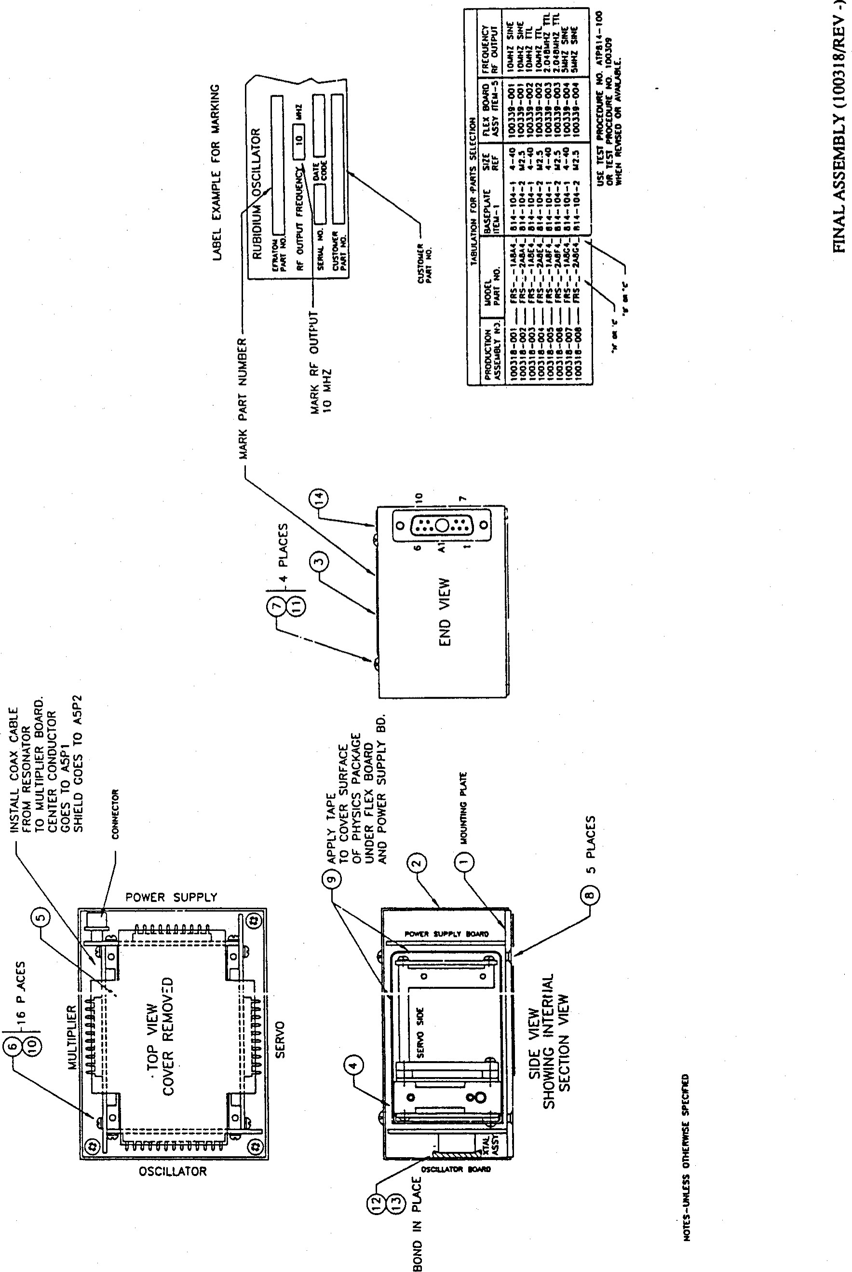

1 

|  |  |  |  |  |
| --- | --- | --- | --- | --- |
| ВАШ,  ТХТЬЕ: | ЕПЛТОМ DIVISION CONTRACT Но.  PARTS LIST, FINAL ASSBOLY, FRS | CAGE CODE 55761 | 100318-00 I | REVISION LTR. в  REVISION DATE 91-5-15 |

SHEET 2

##### FIND QTY PART OR SPEC. OR NOMENCLATURE REFERENCE

Но. REQ IDENTIFING но. MANUFACTURER ОН DESCRIPTION DESIGNATOR UNIS но.

1

2 1 814-105 COVER з 1 100141-001 IABEL, НАМЕРИТЕ 4 1 814-110 PHYSICS PACkAGE ASSEMBLY

#### 5 1 SEE ТАВ ОН SHT 2 FLEX BOARD ASSEMBLY

##### 6 16 MS51957-2 SCREW, РАН Но 2-56х3/16 2821424 7 4 MS51957-13 SCREW, РАН HD 4-40х1/4 2821417 8 5 MS24693C2 SCREWF FLAT Н) 4-40х1/4 2821353

970423-3 ТАРЕ, MYIA.R WXDE)

##### 10 16 MS3533B-134 WASHER, I,OCk НО. 2 2821390

1. 4 MS35338-135 WASHER, LOCk НО. 4 2821391
2. 1 814-127-1 INSUIATOR, MYIAR

#### 13 НОТ USED

14 1 713-040 WA.RRANTY I.,ABEL

PARTS LIST, FTNAL ASSEMBLY

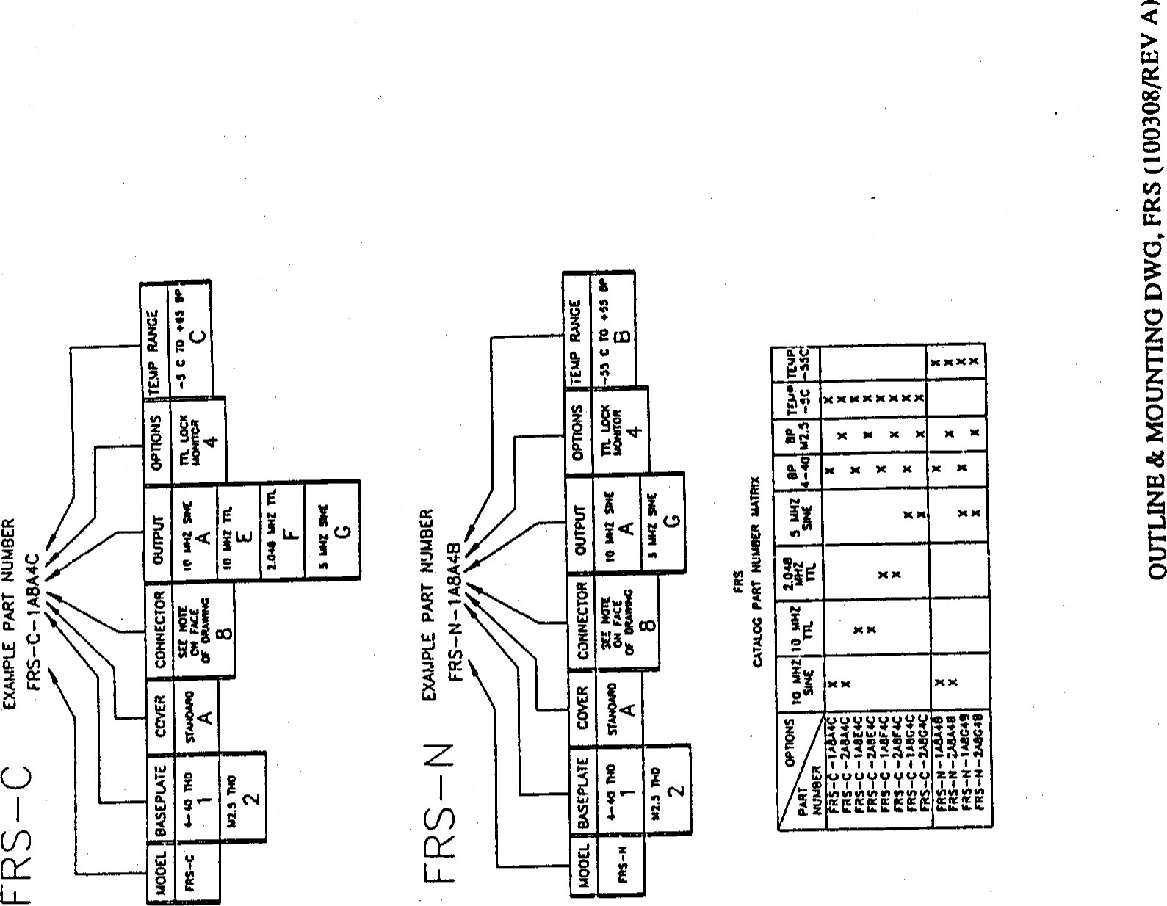

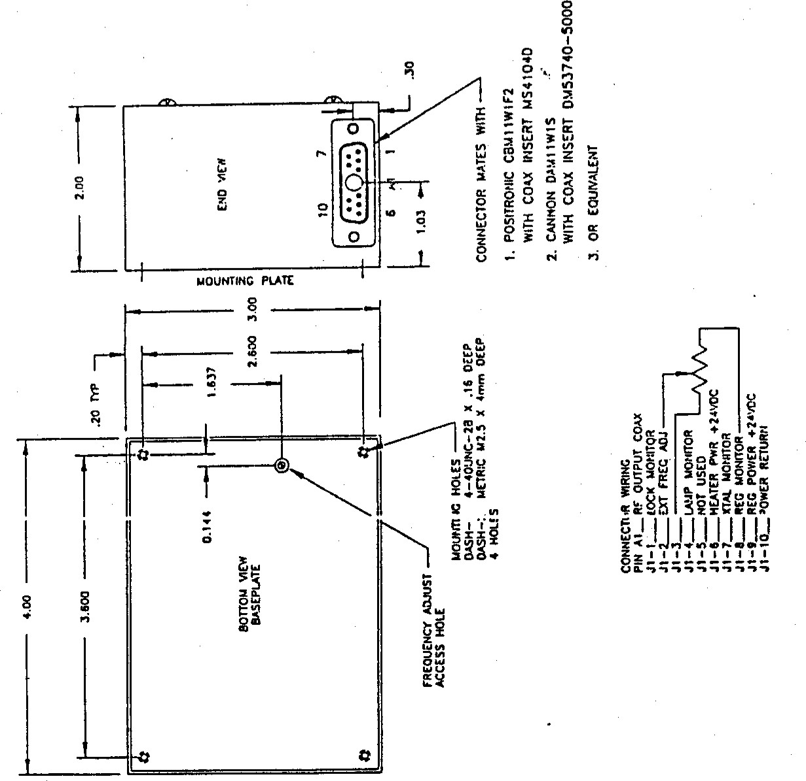



##### 5 SOLDER FLEX BOARD

TO CONNECTORS

ON SIDE BOARDS

CONNECTOR

3 AFTER TESTING

COAT BOTH SIDES

OF SERVO BOARD

WITH CONFORMAL COAT

ITEM-8

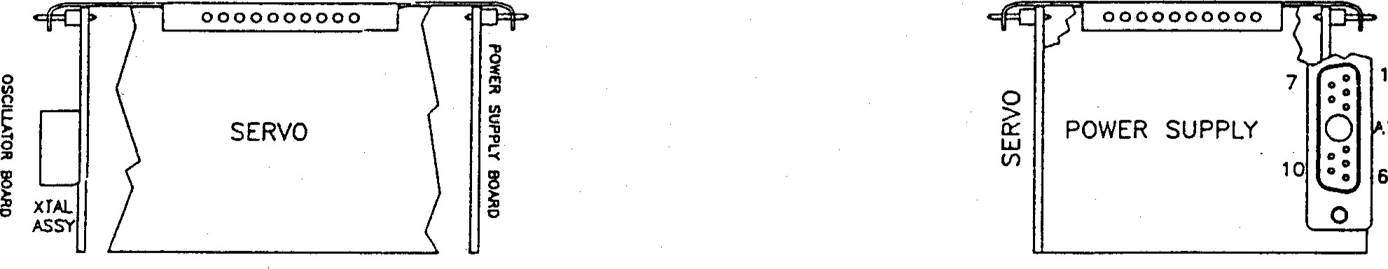

.1



|  |  |  |  |  |  |  |  |  |  |  |  |  |  |  |  |  |  |  |  |  |  |  |  |  |  |  |  |  |  |  |  |  |  |  |  |  |  |
| --- | --- | --- | --- | --- | --- | --- | --- | --- | --- | --- | --- | --- | --- | --- | --- | --- | --- | --- | --- | --- | --- | --- | --- | --- | --- | --- | --- | --- | --- | --- | --- | --- | --- | --- | --- | --- | --- |
|  | |  |  |  |  |  |  | | --- | --- | --- | --- | --- | --- | | FLEX BOARD ASSY NO. | FREQUENCY  RF OUTPUT | TABULATION FOR  OSCILLATOR | PARTS  MULTIPUER  ITEM-2 | SELECTION  SERVO BD. | POWER SUPPLY ITEM—4 | | 100339-001 | 'OMHZ SINE | 814-192-1 | 814-167-1 | 814.145-2 | 814-144—2 | | 100339-002 | IOMHZ TTL | 814-192—2 | 814—167-1 | 814-145-2 | 814—1 44—3 | | 100339-003 | 2.048MHZ TTL | 814-192-3 | 814-167- | 814—'45-2 | 814-144-3 | | 100339—004 | 5MHZ SINE | 814-192-4 | 814-167-1 | 814-145—2 | 814- 44—4 | | 100339-005 | IJMHZ TTL | 101243-001 | 814-157-2 | 814— 2 | 814— 144—3 | |

ASSENBLY, FLEX BOARD (100339[REV B) FRS

BALL, EFRATOM DIVISION CONTRACT No. CAGE CODE 55761 100339-OÖX REVISION LTR. 8.

REVISION DATE 915-91 TITLE: PARTS LIST, FLEX BOARD ASS! , RUBIDIUM FREQ.



##### FIND QTY PART OR SPEC. OR NOMENCLATURE REFERENCE

No. REQ IDENTIFYING No. MANUFACTURER OR DESCRIPTION DESIGNATOR UNIS No.

##### 1 1 SEE TAB ON SHT 2 OSCILLATOR/SYNTHESIZER ASSEMBLY

###### 2SEE TAB ON SHT 2 MULTIPLIER ASSEMBLY 3SEE TAB ON SHT 2 SERVO BOARD ASSEMBLY 4SEE TAB ON SHT 2 POWER SUPPLY ASSEMBLY 5814-134-2 FLEX BOARD(KAPTON)

|  |  |  |
| --- | --- | --- |
| 6 |  | NOT USED |
| 7 | A/R SN63WRMAP3 | SOLDER |
| 8 |  | NOT USED |

PARTS LIST, FLEX BOARD ASSE1vBLY

A-6

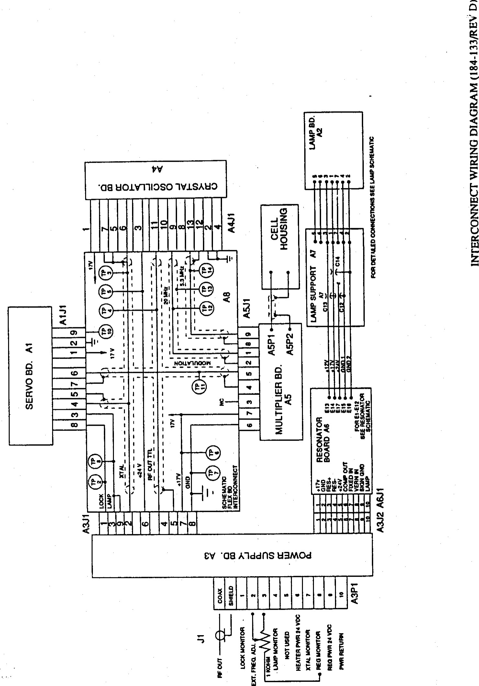

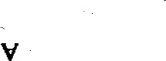

# (生 ミべ一一瞽一8)sa VO ゴ ELM)ddfIS・S盟コ 国SSW



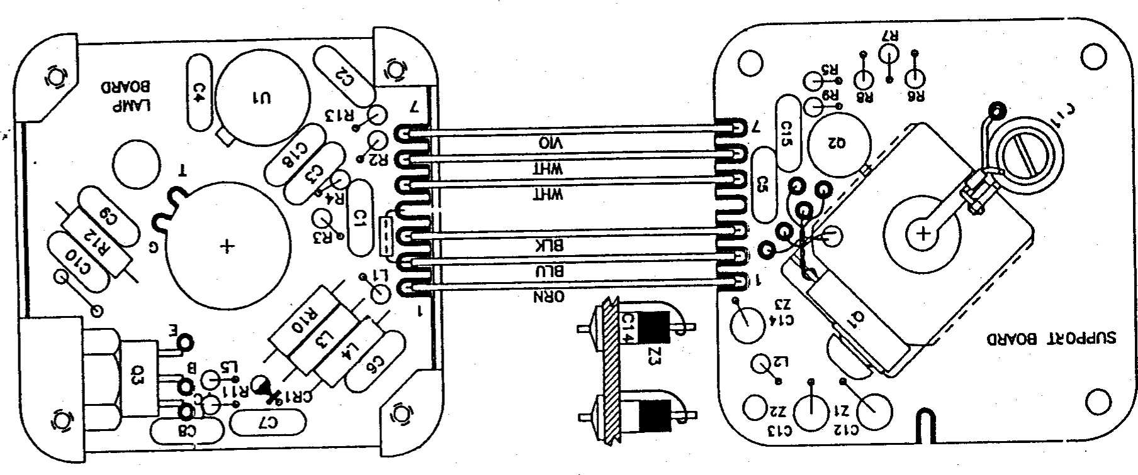

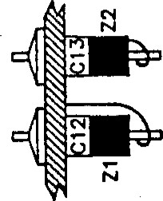

S比」

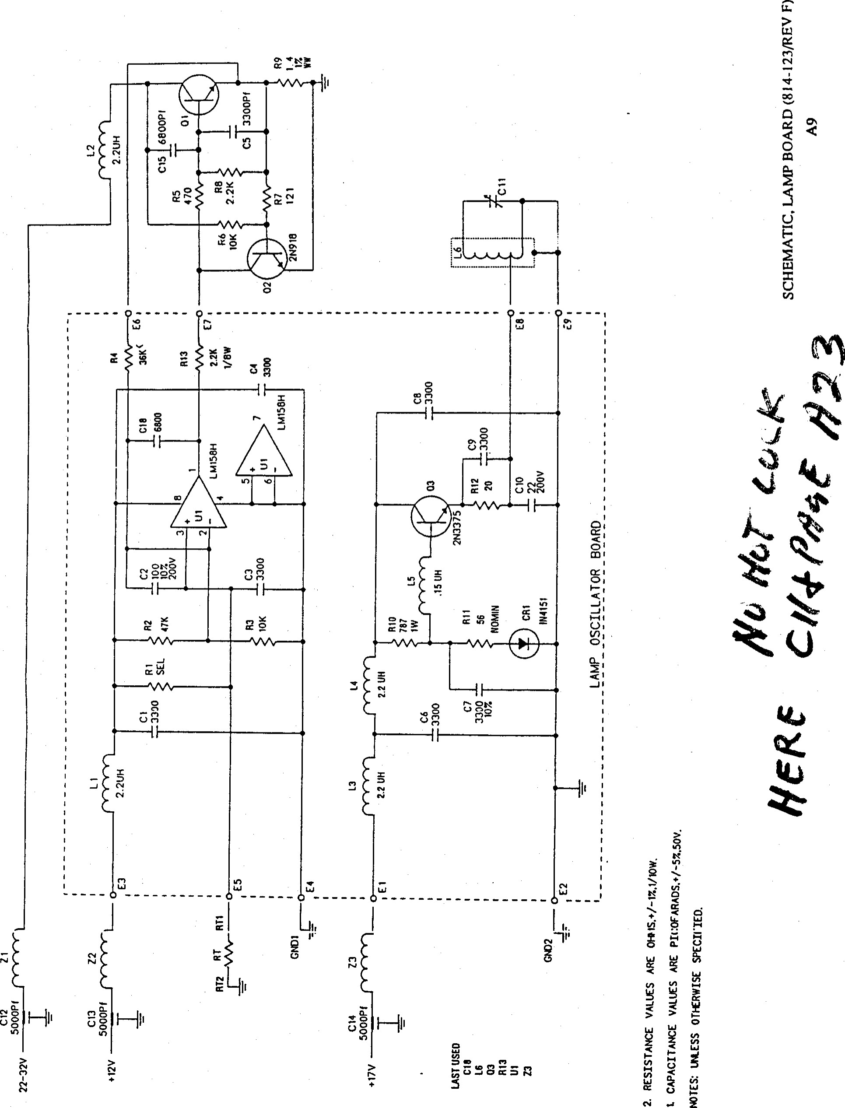

FRS

|  |  |  |  |
| --- | --- | --- | --- |
| BALL, EFRÄTOM DIVISION CONTRACT No.  TITLE: PARTS LIST, I-AMP BOARD ASSY | CAGE CODE 55761 | 814-113 | REVISION LTR. L  REVISION DATE 91-5-13 |

## SHEET 2

### SPEC. OR NOMENCLATURE REFERENCE



FIND

QTY

PART

OR

DESIGNATOR

tJN1s

No.

OR DESCRIPTION

 1 814-115 P.w.B. 814-115

## 2 1 MKI 2.21K RESISTOR, ME, 2.21K OKK, W Ri3 4703035 310K RESISTOR, 10K OHM, 1/8 4703029 4 136K RESISTOR, ME, 36K OHM, 1/8 4703314 5 MX2 56.2 RESISTOR,MF, 56 OHM, 1/4W NCH 4702286 6 NOT USED 7 1 RWR81S7870FR RESISTOR 1 W WIREWOUND 787 RIO 4702028 8 1 RWR80S20ROFR RESISTOR 2 W WIREWOUND 20 OEM R12 4701967 9 1 EDPT 22 PF NPO CAPACITOR, CERAMIC 22 PF NPO CIO 1500742 10 1 CKR05BX101XSV CAPACITOR, CERAMIC 100 PF 1500685

7 C322C332KIG5CÄ XEMET CAPACITOR, CERAMIC 3300 pf NPO6-9 1500580

## 12 1 MS75083-3 INDUCTOR O. 15tJH IS 1801443 13 3 MS75084-4 INDUCTOR 2.2UH 180144B 14 1 IN4i51 DIODE CRI 4800084 15 1 INTEGRATED CIRCUIT 3130993 16 NOT USED 1747.5K RESISTOR, ME, 47K OHM, 4703014

### 1 CKR05BX6B2KSV CAPACITOR 6800PF CIB 1500695

1. 1 705-142 MOTOROLA TRANSISTOR 2N3375 705-142
2.  814-117-1 AMP SPACER

## 21 2 i.iSä1957-4 SCREW, 2-56x5/16 CRES PAN HD 2821434 22 A/R 70411THERMAL JOINT COMPOUND 70411 23 A/R MIL-W-16ü8 TYPE WIRE, 24 STRANDED



NOTES :  ALL STANDUP COMPONZ*TS CO HAVE o 0.02 MIN. CLE.Ä.RANCE ABOVE P.C. B.

### MAY USE RCR05GXXXJR MAY USE RCR07GXXXJR

TO USE TSTR (2N3375) 

MÄDE BY THOMPSON (LOGO"sT N ) MUST USE

RESISTOR RLi(75 OHM) ,HX2) AND INDUCTOR

SEE TAB ON LAMP ASSY AND SCHEMATIC LAMP clP.cUIT.

PARTS LIST, BOARD A2 ASSENBLY (PL814-113/REV L)

A-IO

FRS



BALL, EFRATOM DIVISION CONTRACT No. CAGE CODE 55761 814-112 REVISION LTR. V

### REVISION DATE 91-5-13

#### TITLE: PARTS LIST, I-amp ASSEMBLY



#### FIND QTY PART OR SPEC. OR NOMENCLATURE REFERENCE

No. REQ IDENTIFING •No. MANUFACTURER OR DESCRIPTION DESIGNATOR UNIs No.

814-116

2 814-117-2SPACER

## 3 6 MS51957-3 SCREW, 2-56X1/4 CRES PN HD 2821428

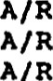4LOCKTITE *222 COMPOUND, THREAD LOCKING 5MIL-W-16B78E WIRE, 2B AWG STRANDED 6SN63WRHAP3 SOLDER

7 A/R 704-215-1 WIRE, 26AWG,  TNPER 1.6 (9 TURNS) 8 1 100299-001 LAMP HOUSING ASSE{BLY 9 A/R 70424-12 ADHESIVE RTV, BLACK 10  70424-7 ADHESIVE RTV 10B

11 1 100297-001 COIL FORM

## 12 3 1126-1115-502AD CDI CAPACITOR, FEED THRU Ci2-i4 1500032 13 1 9053 CAPACITOR, VARIABLE i. 5-14PF o 1 B57232-A1i03-MTHERMISTOR (MB5) 5301106 15 AMS-3655 TUBING, TEFLON 30 AWG LEADS OF RT 16 NOT USED 17 1 814-113 LAMP BOARD ASSEMBLY

.18 1 814-120-2 LAMP, FILLED -19 AHS-3655 TUBING TEFLON 26

## 20 NOT USED 21 1 MJE802 TRANSISTOR 4801151 22 NOT USED 23 NOT USED 24 1 BS2200F006 WASHER BELLEVILLE 2820531 25 1 MS51957-14 SCREW, PAN HD 4-40x5/16 2821418 26 NOT USED 27 NOT USED 28 NOT USED 29 A/R 70411 THERMAL JOINT COMPOUND 30 1 814-158 PLUG-LAMP COIL



31 3 2643000101 FERRITE BEAD Zi-3 1850160

## 32 1 MS750B4-4 INDUCTOR 2.2UH 180144B

33  2N918 TRANSISTOR 4800210

## 34 C322C332KIG5CA KEMET CAPACITOR 3300PF NPO 1500580 35 1 CKR05BX682XS CAPACITOR 6800 PF Ci5 1500695 36 MRI 121 RESISTOR, MF, 121 OHM, 1/8 W 4703010 37 1475 RESISTOR, ME, 475 OEN, 11B W R5 4703358 3810K RESISTOR, MP, 10K W 4703029 39 1 RWR8iSIR4 OFR RESISTOR 1.40 ohm WW 4702014 40 43-77-1 THERMALLOY INSULATOR (THERMALFILM) XQi 1002594 41 1 MRI 2.21K RESISTOR, MF, 2.21K OHM,4703035

NOT USED 43  250-169 MICA WINDOW o NOTE:MAY USE THERMOMETRICS BR55KB103-L

1.8 LONG

 MAY USE RCR05GXXXJR

PARTS LIST, SUPPORT BOARD A3 ASSEMBLY (PL814-112/REV V)

### A-Il

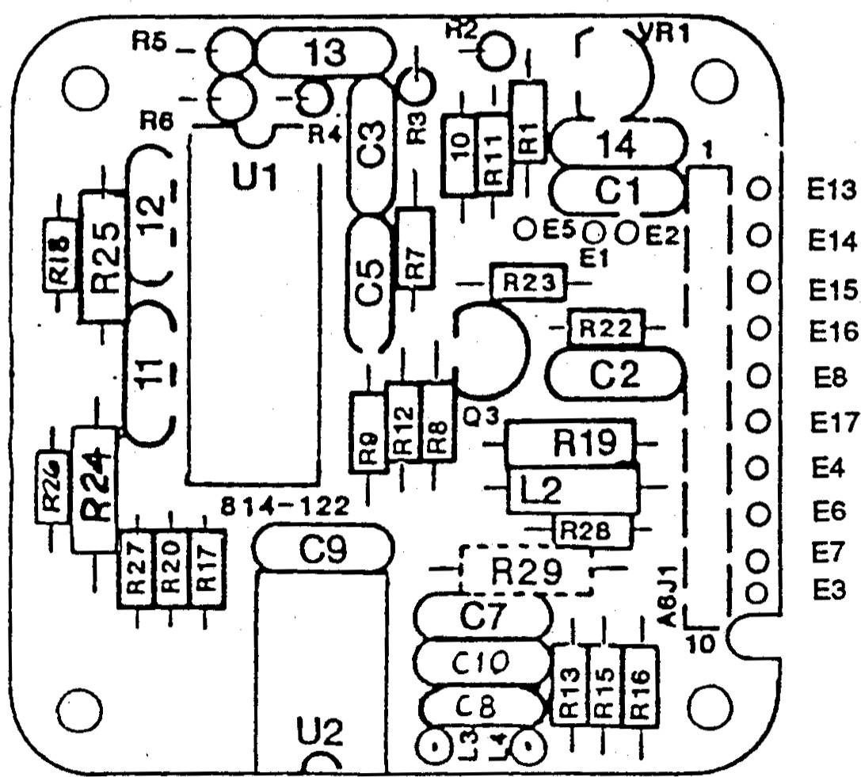R29 IS MOUNTED ON SOLDER SIDE

DURING TEST

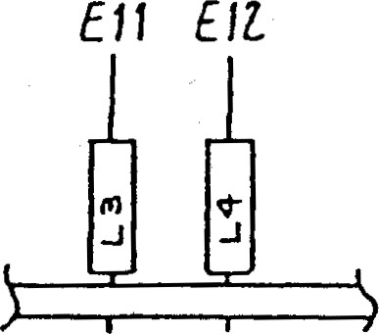

ASSEMBLY A6, RESONATOR BOARD (814-122/REV R)

A-12





ElV

(dAAU/EZ一瞽一8)0 V090トVNO 区び g工OS

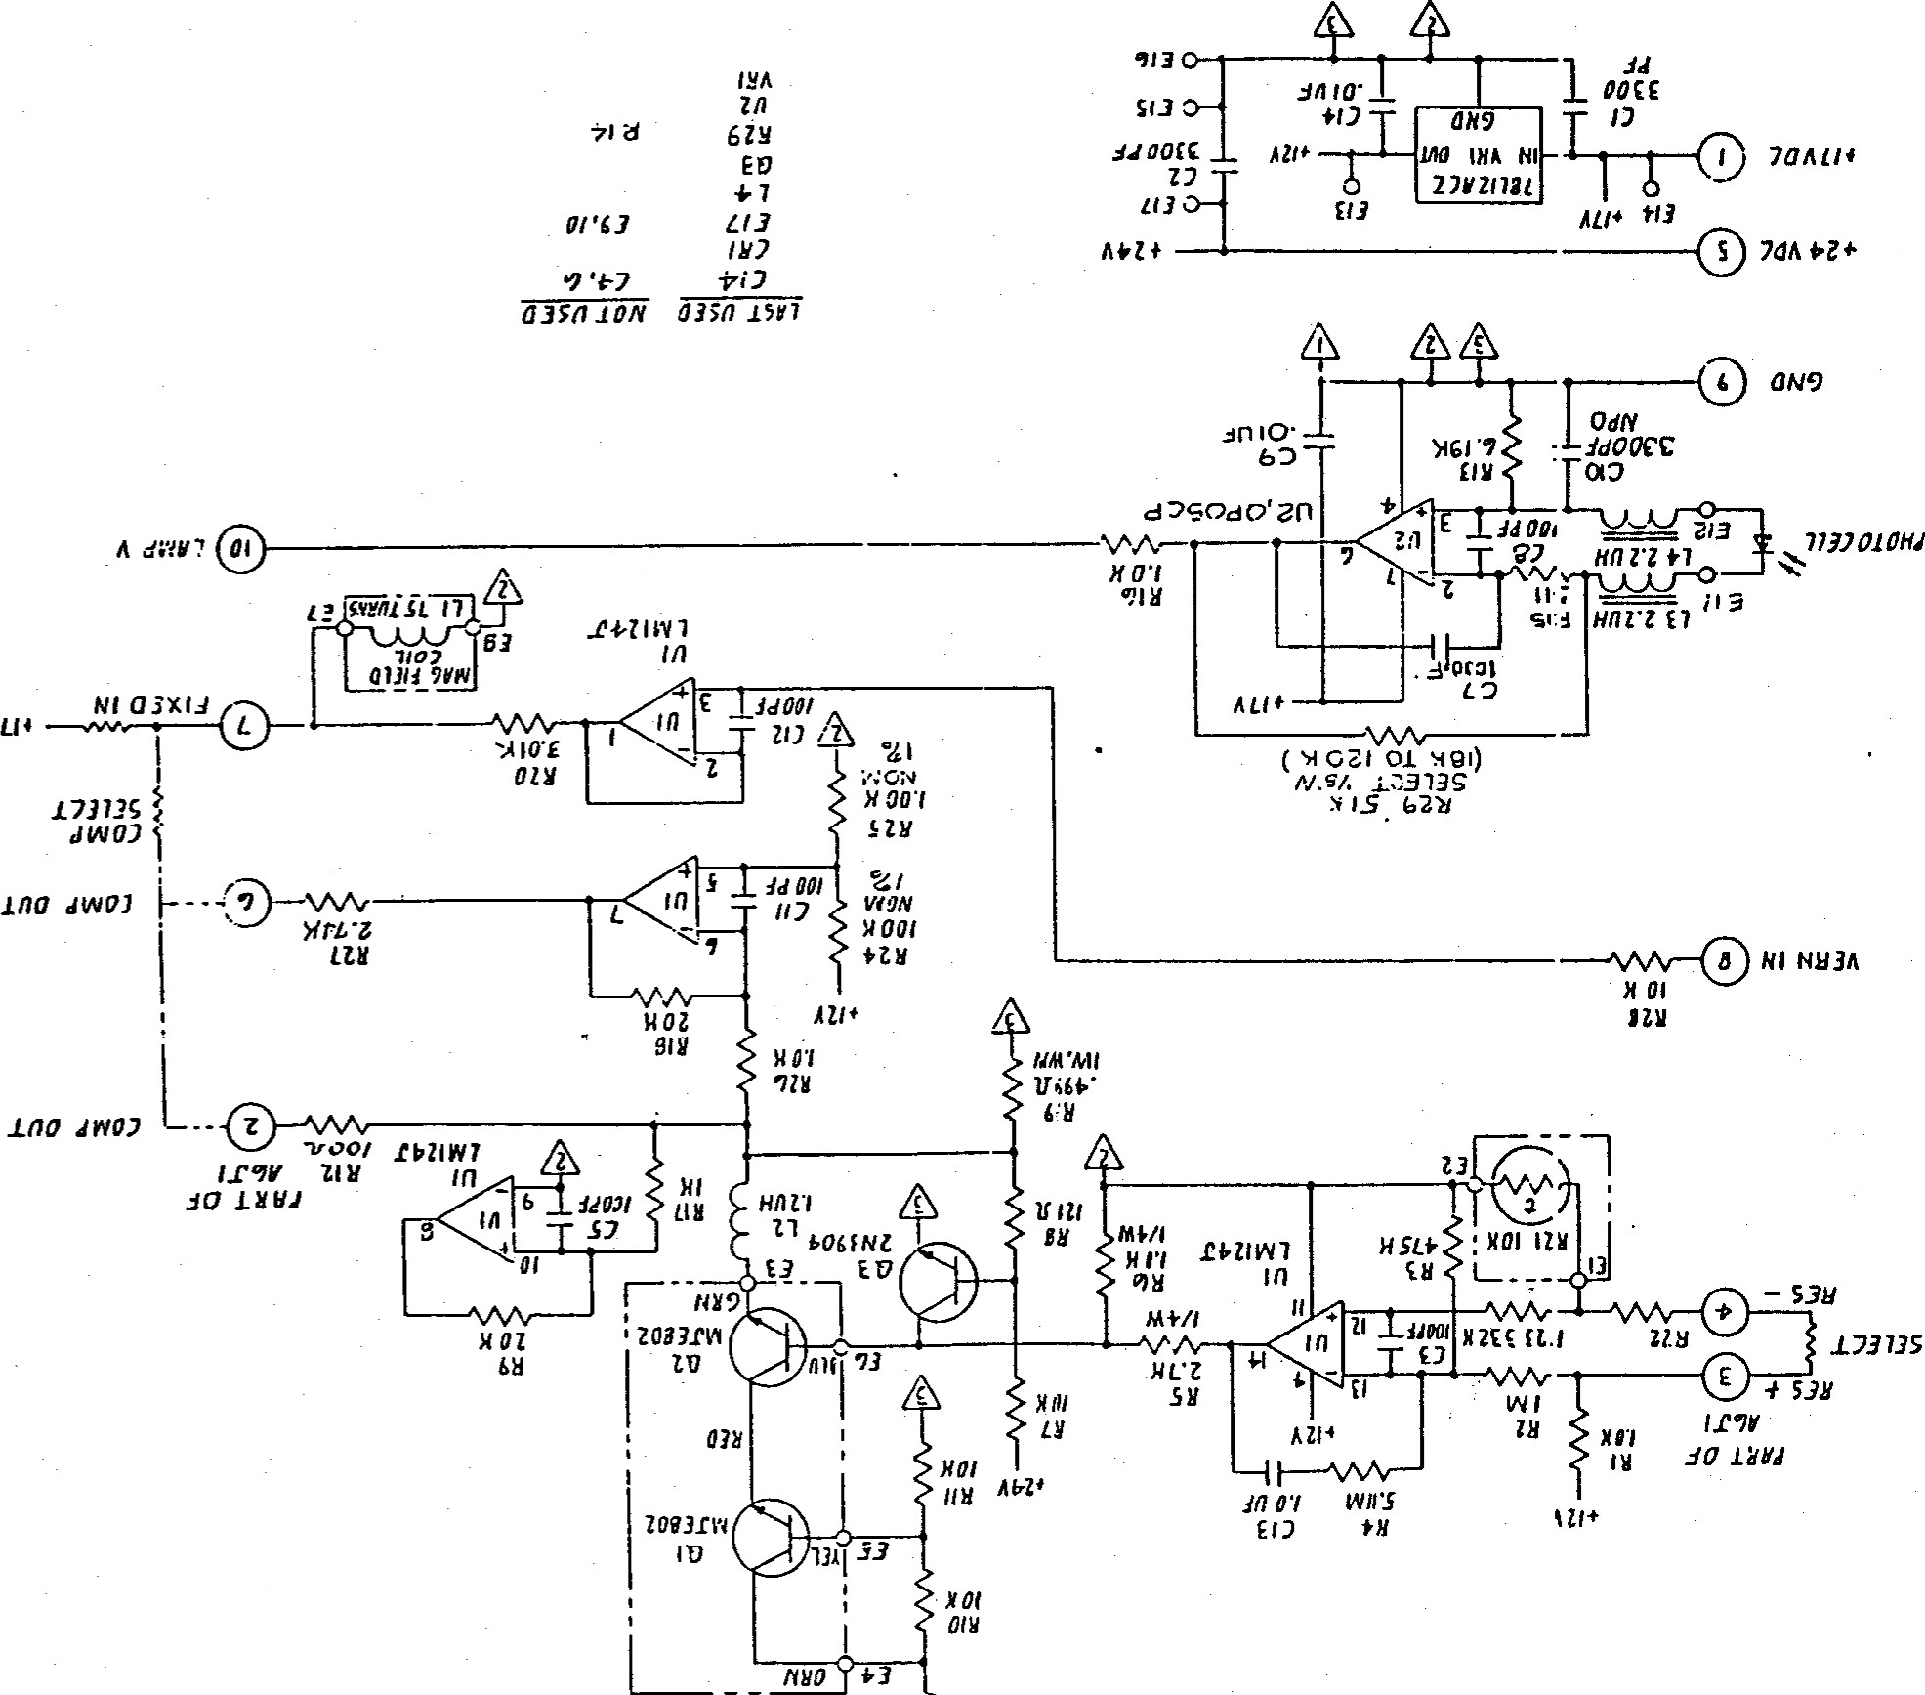

ALI*



FRS

|  |  |  |  |  |
| --- | --- | --- | --- | --- |
|  | | TABULATION CHART | |  |
| AS.sæSLY |  | ASSZOt-Y | VA.LÆS | a.nm.rr |
|  | R 87. | e.ooer NON  NON |  |  |

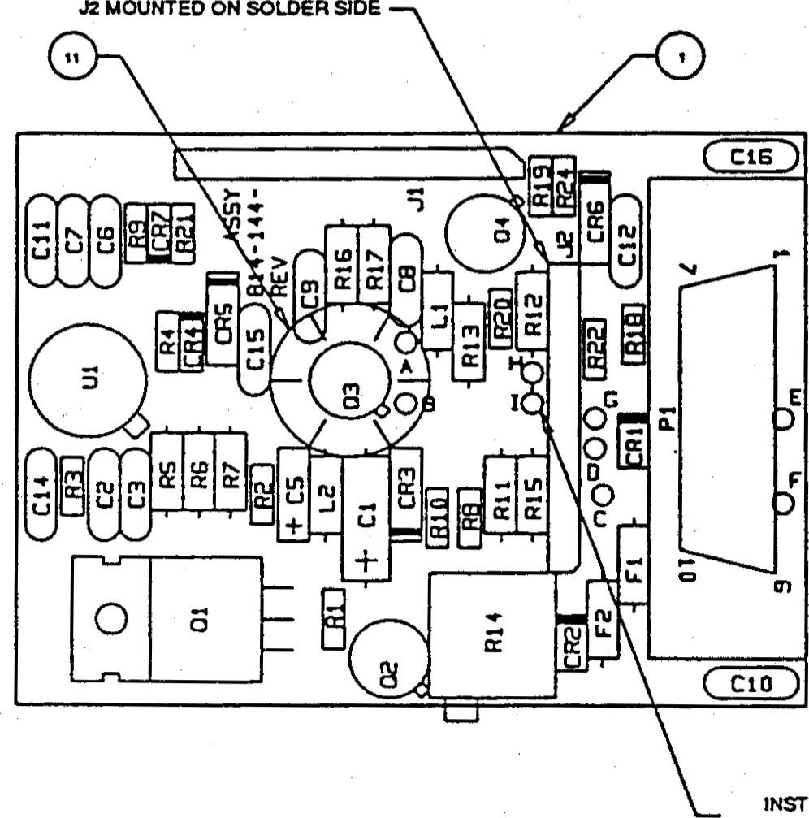spear—.



•

a



t.

PG

#### Z AX SHAL kET T'•e

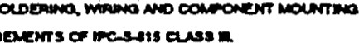

æamexexrs

TO sane—a.

1. CLEM ASS.ew.YTO N.Z-
2. meNtFY ASSY PARTS t.BT REV. L.rrrm.

6. 

7. FOR

INSTALL LEAD OF R12 'N PAD H FOR + COMPENSATION

INSTALL LEAD OF R12 IN PAD 1 FOR COMPENSATION

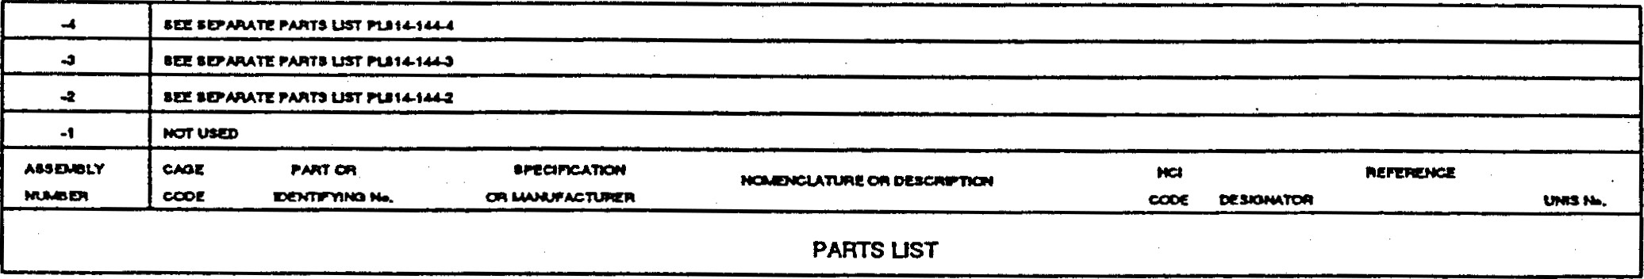

ASSEtvBLY A3, POWER SUPPLY BOARD (814-144/REV P)

15

#### FRS

BALL, EFRATOM DIVISION CONTRACT No. CAGE CODE 55761 814-122 REVISION LTR. 

REVISION DATE 91-4-3

#### TITLE: PARTS LIST, RESONATOR BOARD ASSEMBLY FIND QTY PART OR



NOMENCLATURE

REFERENCE

No. REQ IDENTIFING No. MANUFACTURER OR DESCRIPTION DESIGNATOR UNIS No.

|  |  |  |  |  |  |
| --- | --- | --- | --- | --- | --- |
| 1 | 1 814-124 |  | P.C. B. |  |  |
| 2 | BBL-IIO-G-F | SAMTEC | CONNECROR | Ä6Ji | 2100542 |
| 3  4 | A/R SN63WRM.AP3 |  | SOLDER  NOT USED |  |  |

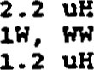 5 2 MS75804-4 INDUCTOR1801448

## 6 RWR8 99 FR RESISTOR .499 Ohn Ri9 4702034 7 MS75084-1 INDUCTOR 1801444 B 1 RCR07G102JR RESISTOR 1/4 W CARBON i. OX 4701686 9 1 RCR05CXXXJR SELECT IN TEST RESISTORW CARBON, SIT R29

1 RCR07G272JR RESISTOR 1/4 W CARBON 2.7K 4701715

## 11 1100K RESISTOR, METAL FILM 100K R24 4701170 12 MX2 1.00K RESISTOR, METAL FILM i. OOK R25 4701153 13 1 2N3904 TRANSISTOR NPN Q' 4800197 14 1 CK06BX105XSV CAPACITOR, CERAMIC 1. our 1500697 15 5 C320C101X2S5CA CAPACITOR, CERAMIC IOOPF NPO 1500565 16 2 RCR05Gi01JR RESISTOR 100 ohm 1/8 W CARBON Ri2 , 15 4701599 17 3 C322C332KIC5CÄ XZMET CAPACITOR, CERAMIC 3300pF NPO Cl. 2,10 1500580

3 CXR05B.X103KSV CAPACITOR CERAMIC .01 uF C? , 9.14 1500687

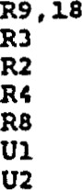19 1 RCR05G334JR RESISTOR 1/8 W CARBON 330K R23 4701642 20 4 RCR05G102JR RESISTOR W CARBON 1. OX  4701600 21 1 RCR05C272JR RESISTOR 1/8 W CARBON 2.7K R27 4701634 22  RCR05G622JR RESISTOR 1/8 CARBON 6.2K R13 4701661 23 4 RCR05Gi03JR RESISTOR 1/8 W CARBON 10K RIO , 11.7, 28 4701601 24 2 RCR05G203JR RESISTOR 1/8 W CARBON 20K4701623 25 1 RCR05C474JR RESISTOR i/B W CARBON 470K4701652

26 1 RCR05G105JP. RESISTOR 1/8 W CARBON 1.0M4701604

## 27 1 RCR05G515JR RESISTOR 1/8 W CARBON 5.1M4701655 28 1 • RCR05Gi2iJR RESISTOR 1/8 CARBON 120 ohm4701526 29 LM124J INTEGRATED CIRCUIT 3130985 30 OP05CP PMI ONLY INTEGRATED CIRCUIT 313001S 31 78Li2ÄCZ VOLTAGE REGULATOR VRI 4002225 32 RCR05G302JR RESISTOR 3.0 K R20 4701637

PARTS LIST, RESONATOR (A6) BOARD ASSErvBLY (PL814-122/REV T) 

14

9一V



## (トA ミ ・寸一8)0 V08AIddflS区 0生び洋VW盟工DS



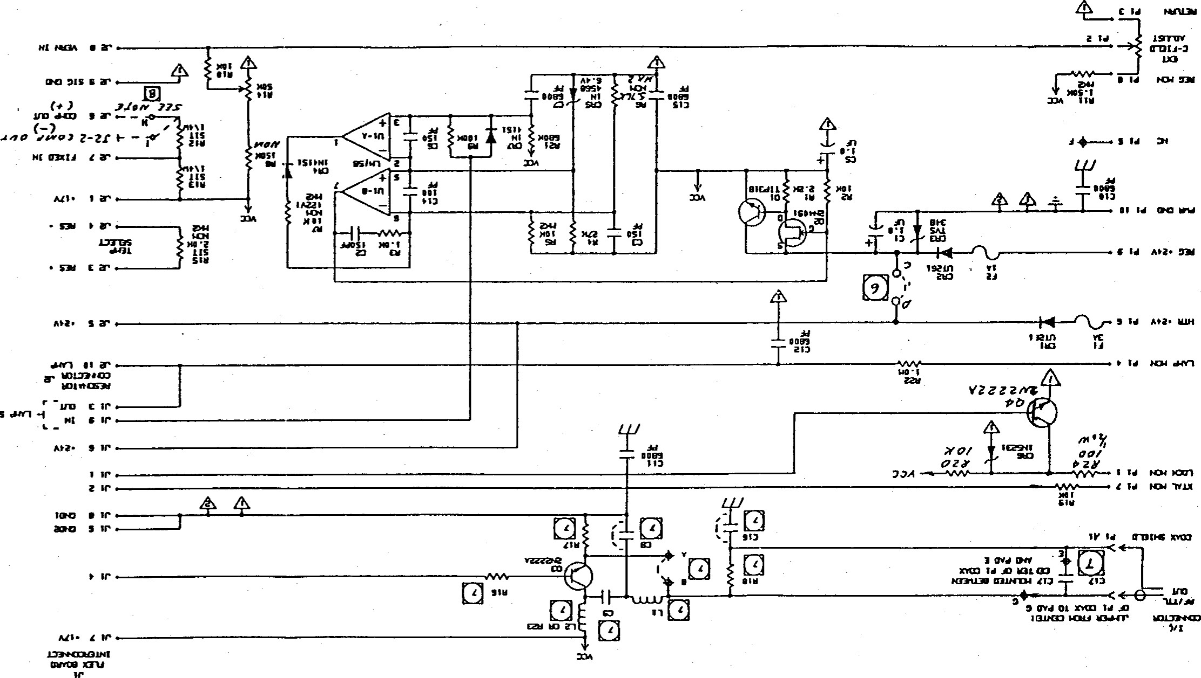

0-

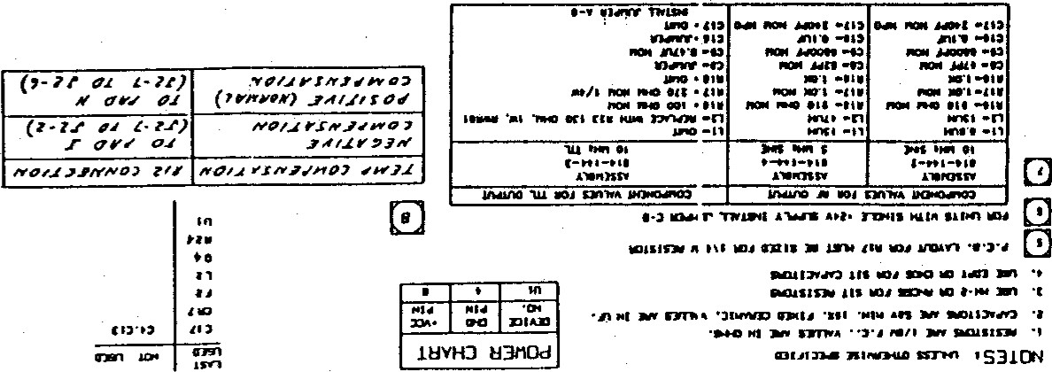

### FRS

|  |  |  |  |
| --- | --- | --- | --- |
| ВАС, | ЕП.АТОМ DXVISIOU сонтпст | САСЕ CODE 55761 | Р Т- 314-144-3  RZVXSXON DkS 91-4-3 |
| TITLE: | PARTS POWER SUPPLY ASS? |  |  |

SiiE;: 2

2 з 2 SCREH, ЗАСК SOCkET



814-148

4750-5

RAF

sxttk

### 4 MS51957-i4 SCREH, РАН НО, 4-40х5/16 2821418

1.  5607-45 SEASTROM HASHER, SHOVLDER 2820391
2.  MS3533B-135 HASHER, LOCk $4 2821391 7 NAS620C4L HASHER, ГИТ $4 2821452 kFS2-440 РЕМ НИТ, CAPTIVS 2620954 9 2 NAS671C4 НИТ, НЕХ,2822486  ТХС20В IERC натынк  XQ3 26C2125 12 1 3223-07FR-54 AAVXD r.•zsur..AT0R XQ1 3100241
3. з 7717-хззн THERMALLOY IHSt;r.ATOR ТО-1В XQ2 , хаз , XQ4 2102218
4. 704-232 ВОСТХТЕ сомРОИНО, ТНПЕАО
5. AlR MIL-a-16B7B нхяЕ, 28 АНС STPAHOED ТУРЕ 

17 AlR SH63W*MAP3 QQ-H-37i SOLDER

### 20 1 ciQ05M(101ks MIL-c-39014 CAPACXTOR. CERAMIC 100 PF С14 1500635 21 з CkR05BX151kS MIL-c-39014 CAPACITOR . CERAMIC 150 РЕ 2500689

1.  CkR05BX682kS MIL-c-390i4 CXPACITOR , CERA.MIC 6800 lS00695
2. 6 CkR05BX6B2kS MIL-c-39014 CAPACITOR, CZRAMIC 6800 7,10-12.15 150069S
3. 1 74M5U5CA КЕМЕТ CAPACITOR. CER.AMIC 0.47lS03032
4. 173DX05X9050V SPRAGGE схпсхтан, тхнтжшн 1.01500072

### 28 1 cSR13G105k MIL-c-39003 САРАСХТОР., ТАНТАЫЛ4 1.0 150070B 29 2 1.Ч4151 DXODE CR4 , CR7 4ВОООБ4 зо lN*56B DIODE CR5 4800085

#### 1N523iB DIODE, ZENER CR6 4800090



### 32 TVS348 С23 4802259 33 2 UT261 D10DE CRl , CR2 4602136

 251001 EITTELFUSE FUSE ХА 4300180

### 35 251003 LITTELFUSE FUSE4302506

36  CA-S09-20T-40-125 СА CORP СОННЕСТОй 2102502

### 37 SS-1XO-G-2 SX'TEC COHNECTOR 32 2102090

PARTS LIST, POWER SUPPLY (АЗ) ASSEMBLY (PL814-144-3/REV К) (PAGE 1 OF 2)

А-17

 FRS

|  |  |  |  |
| --- | --- | --- | --- |
| BALL, | EFRATOH DIVISION CONTACT NO. | CAGE CODE 55761 | PL ai4-144-3 REVISXON '...TR. X RZV:SION DATE |
| TITLE: | PMTS LIST, POWER SUPPLY |  |  |

SHEET

FIND QTY PART OR SPEC. OR NOMENCLATURE REFERÄCE tmxs NO .

NO. IDENTIFYING NO. MANUFACTURER OR DESCRIPTION DESIGNATOR

2102722

FDS420iD 2103287 44 2 2N2222A TRANSISTOR 4800188

1.  2N409i TRANSISTOR 4800199
2. 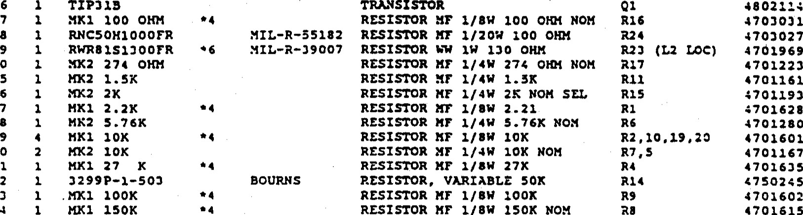TIP3i3 TRANSISTOR
3. RESISTOR

48

49

50

1. RESISTOR
2. 1 KK2 2K RESISTOR 57 HX1 2.2K RESISTOR

MK2 5.76K RESISTOR 59 HKI 1 ox RESISTOR so 2 KX2 10K  RESISTOR

1. MXI 27 x RESISTOR
2. 3299P-i-503 BOURNS RESISTOR, VARIABLE 50K
3. 1 .MXI 100K RESISTOR KF i/BW 100K 4701602
4. 150K RESISTOR 28 4701615

 RCR05C6B4JR MIL-R-3900B RESISTOR FC 1/8* 630K 221 4701664

1. RCR05GiOS5R MIL-R-3900B RESISTOR rc R22 4701604
2. 2 MK2 SIT RESISTOR MF 1/4'* NON (OPEN) R12.13
3.  1..M15aH l.c. OP MP 3130993
4.  RESISTOR MF i/BW 4 703 r: i

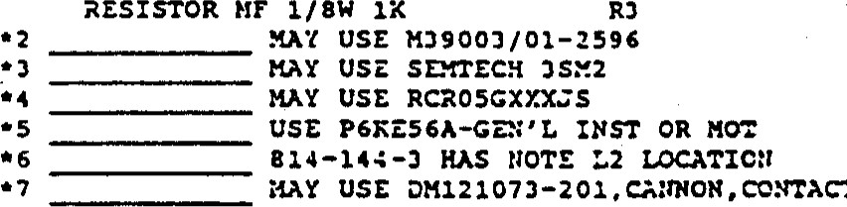

CONTACT

CO>.x

NOTES: REF

REF

REF

REF

PARTS LIST, POYVER SUPPLY (A3) ASSEMBLY (PL814-144-3/REV K) (PAGE 2 OF 2)

A-18

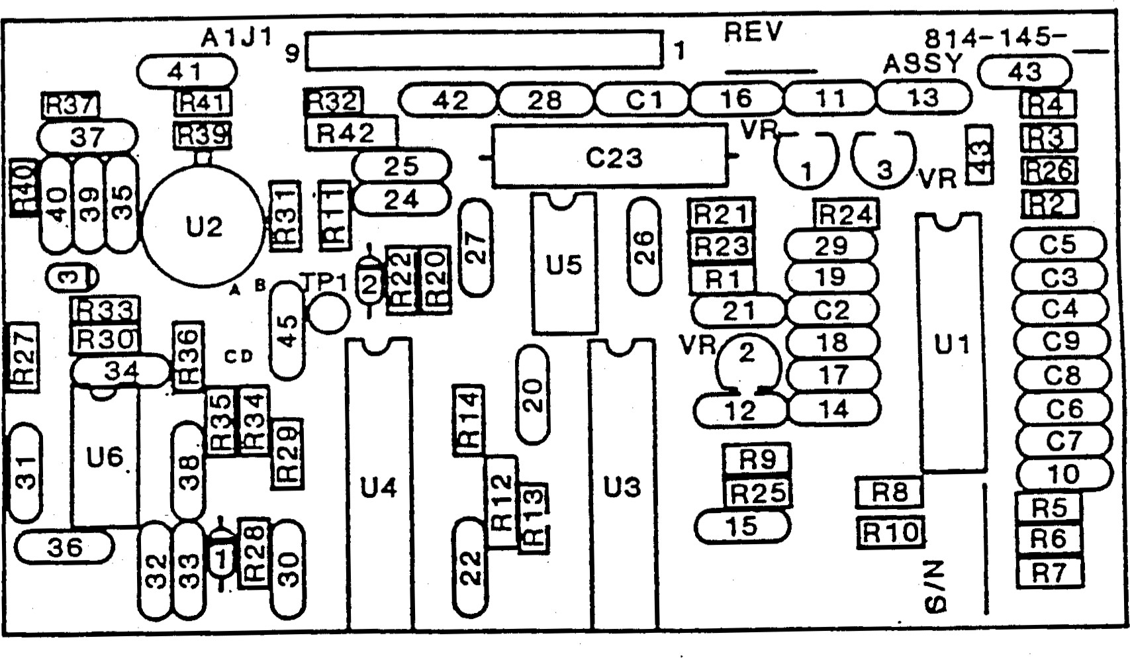

(Al) ASSEvBLY, SERVO BOARD (814-145/REV G)

FRS

BALL, EFRATOM DIVISION CONTRACT No. CAGE CODE 55761 814-145-2 REVISION REVISION LTR. DATE U91-4-3



REFERENCE

#### FIND QTY PART OR SPEC. OR NOMENCLATURE

No. REQ IDENTIFING No. FLANUFACTÜRER OR DESCRIPTION DESIGNATOR No.

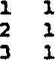

1

P.C. B. 814-141

814-141

### CIRCUIT ASSY CONNECTOR 2102502 70416-2 TERMINAL 70416-2

CA-S09-20T-40-i25

NOT USED

5MK2 5.11K RESISTORM.F. 5.11K NOM 4701276

### 6 1 MK2 442K RESISTOR 1/48* M.F- 442K R12 470268B 7 1 RNC55H7322FR RESISTOR 73.2K +/-1* R23 4702357 B 1 MX2 68.1KRESISTOR 1/4 M.F. 68.1K R24 4701295 9 NOT USED 10 1 RCR05G102JR RESISTOR I/BW CARBON i. OK R21 4701600 11 1 RCR05G512JR RESISTOR 1/8W CARBON 5.1K RI 4701653 12 310K RESISTOR I/BW 10K M.F.4701601 13 1 RCR05G333JR RESISTOR I/BK CARBON 33K4701641

.14 NOT USED

15 1 RCR05G224JR RESISTOR 1/8W CARBON 220K R41 4701629 16 NOT USED 17 6 RCR05G104JR RESISTOR i/8W CARBON 100K 4701602

1B NOT USED

### 193 RC205C334JR RESISTORCARBON 330K 236,47016<2 20 2 RCR05C205JR RESISTOR 1/8W CARSON 2 . 0M NOM R20,22 4701625 RCR05G105JR RESISTOR I/BW CARBON 1.0M RI 3, 28,37 8 4701604 4 RCR05G205JR RESISTOR i/8W CARBON 2.0M4701625 23 3 RCR05G475JR RESISTOR i/BW CARBON 4.7M4701605 24 2 RCR05G106JR RESISTOR 1/8* CARBON IOM 231,33 4701605

25 1 RNC50H2003FR RESISTOR 200K +/-1* R43 4701784 26 1 RNC50H34B2FR RESISTOR 34.8K +/-i% R26 4701801

### 27 NOT ÜSED 28 NOT USED

NOT USED

 7 CKR05aXIOiKSVCAPACITOR, CERN•f1C 200pf1500685

:n 1 C#.R05BX331KSV CAPACITOR, CERAMIC 330pf 1500691

### 32 1 CXR05BX561KSV CA?ÄCITOR•, CERAMIC 560pf 1500694

PARTS LIST, SERVO (Al) ASSEMBLY (PL8 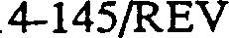U) (PAGE 1 OF 2)

BALL, EFRATOM DIVISION CONTRACT No.

FRS

CAGE CODE 55761 814-145-2 REVISION LTR.

#### REVISION DATE 91-4-3

TITLE: PARTS LIST, SERVO BOARD ASSEMBLY

##### FIND QTY PART OR SPEC.NOMENCLATURE REFERENCE

|  |  |  |  |
| --- | --- | --- | --- |
| 33 | CXR05BX582XSV | CAPACITOR. | CERAMIC 6800pr |

 No. REQ IDENTIFING No. MANUFACTURER OR DESCRIPTION DESIGNATOR UNIS No.

1500695

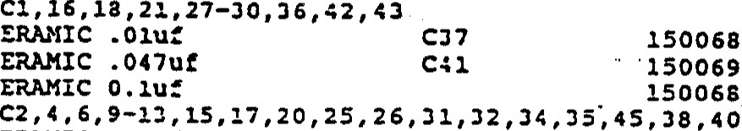

CERAMIC

CERAMIC

CERAMIC

1500687

1500693

15006Ba

### 34 1 CKR05BX103KSV CAPACITOR, 35 1 CKR05BX473KSV CAPACITOR, 36 20CKR05BX104XSV CAPACITOR,

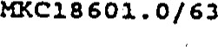 37C320C101R2G5CÄ CAPACITOR, CERAUIC 100pC NPO C22 1500565

### 38 1CAPACITOR, CERAMIC C23 1501323

#### 39NOT USED

1. NOT USED
2. NOT USED

### 42 1 IN4151 DIODE CR2 4800084

43 NOT USED 44 NOT USED

### 45 1 LM340LÄZ5.O VOLTAGE REGULATOR SV VR3 < 001007 46 2 78L12XCZVOLTÄCE REGULATOR 12V4001022

-4712-1158B INTEGRATED CIRCUIT3120993 48LN106J-B INTEGRÄTZD CIRCUIT3130982

### 491 12-11245 INTEGRATED CIRCUIT3130985 50 1 1.213933 INTEGRATED CIRCUIT2131012

51CD4053BF INTEGRATED CIRCUZT3130568 52CD4060BF INTEGRATED CIRCU123130670 o NOTE: 1. MK-I RESISTORS MAY BE USZD PLACE o OF RCR05GXXXJS

2. CRI CR3 ARE NOT USED

#### PARTS LIST, SERVO (Al) ASSENDLY (PL814-145/REV U) (PAGE 2 OF 2)

|  |
| --- |
| 5. |

SLEEVE STAND—UP RESISTORS R3. R4. R9. R13 USING CLEAR

HEATSHR)NK TUBING (TTEM 43). rwSTZE

|  |
| --- |
| 4. |

BOND INSULATOR FOAM (ITEM 41) TO CRYSTAL ASSf (ITEM 2) USING RN *DHESBÆ (rTEM 42) AS SHC*N.

|  |
| --- |
| 3. |

IDENTIFY wrnq ASSEMBLY DASH NUMBER. AND REVISION LETTER-

|  |  |  |
| --- | --- | --- |
|  | | TABULATION |
| PRODUCTION .asst NO | OUTPUT | BOARD  MODIFICATION |
| 814-192-1 | 10 MHz  SINE | AS SHOWN. NO JUMPERS |
| 814-192—2 | 10 MHz | REPLACE R7 JUMPER DO NOT INSI*U L4 OR C17 |
| 814-192-3 | 2.048 MHz | CUT AT 02-11 JUMPER '02-9 TO R7 JPJ-I TO JPJ-J  CUT AT U2-10 JUMPER U2-9 TO U3-9 JPI  CUT AT U2-4 JUUPER U2-3 TO US-to JP2 REPLACE R7 wm.l JUMPER |
| 814-192-4 | 5 MHz  SINE | CUT AT In-it JUMPER U2-10 TO R7 JP3-1 TO JPJ-2 REPLACE R7 WTH JUMPER DO NOT INSTAL u OR C17 |

2. FOR SCHEMATIC SEE 814-201.

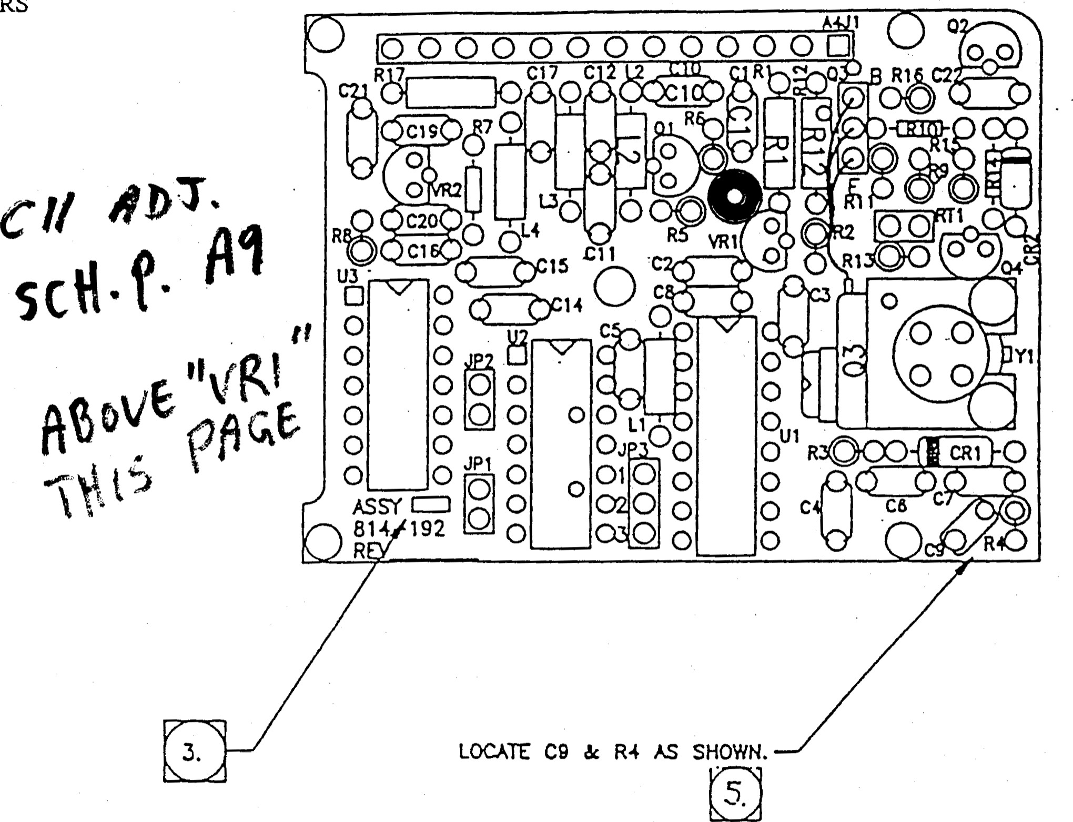

FRS

1. PART ATTACHMENT. WIRING, SOLDERING, CtEANlNG WORKMANSHIP BE JN ACCORDANCE WITH PC-S-815 CUSS UI.

NOTES: UNLESS OTHERWISE SPECIFIED.

##### ASSENBLY A4, OSCILLATOR BOARD (814-192/REV T)

0 V

( >9ミ0マ一 一8)0 V09OA区9の・0 v←

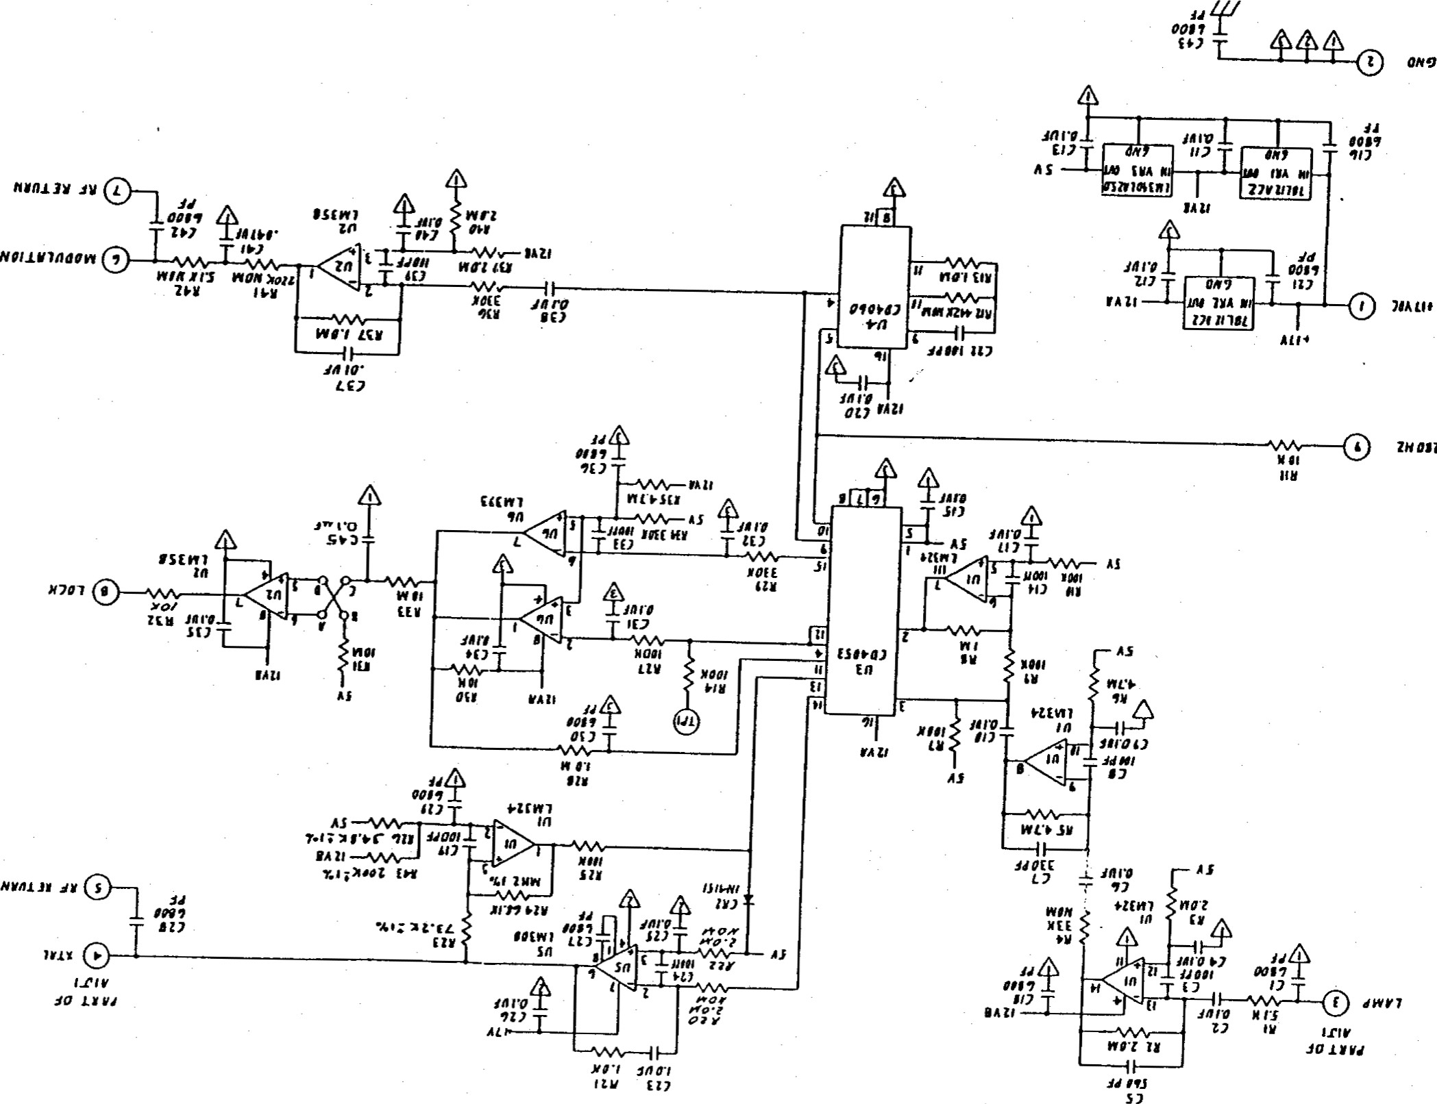

・

OJZ

S

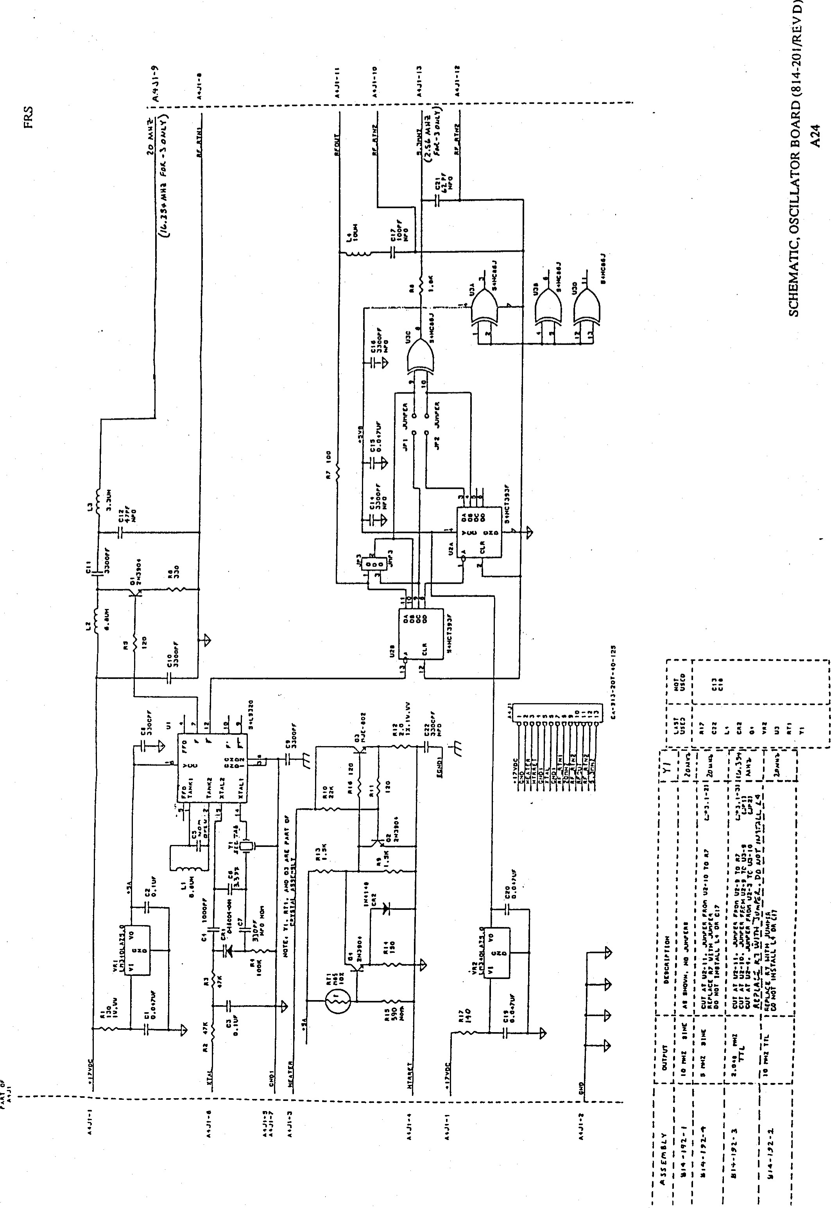

### FRS

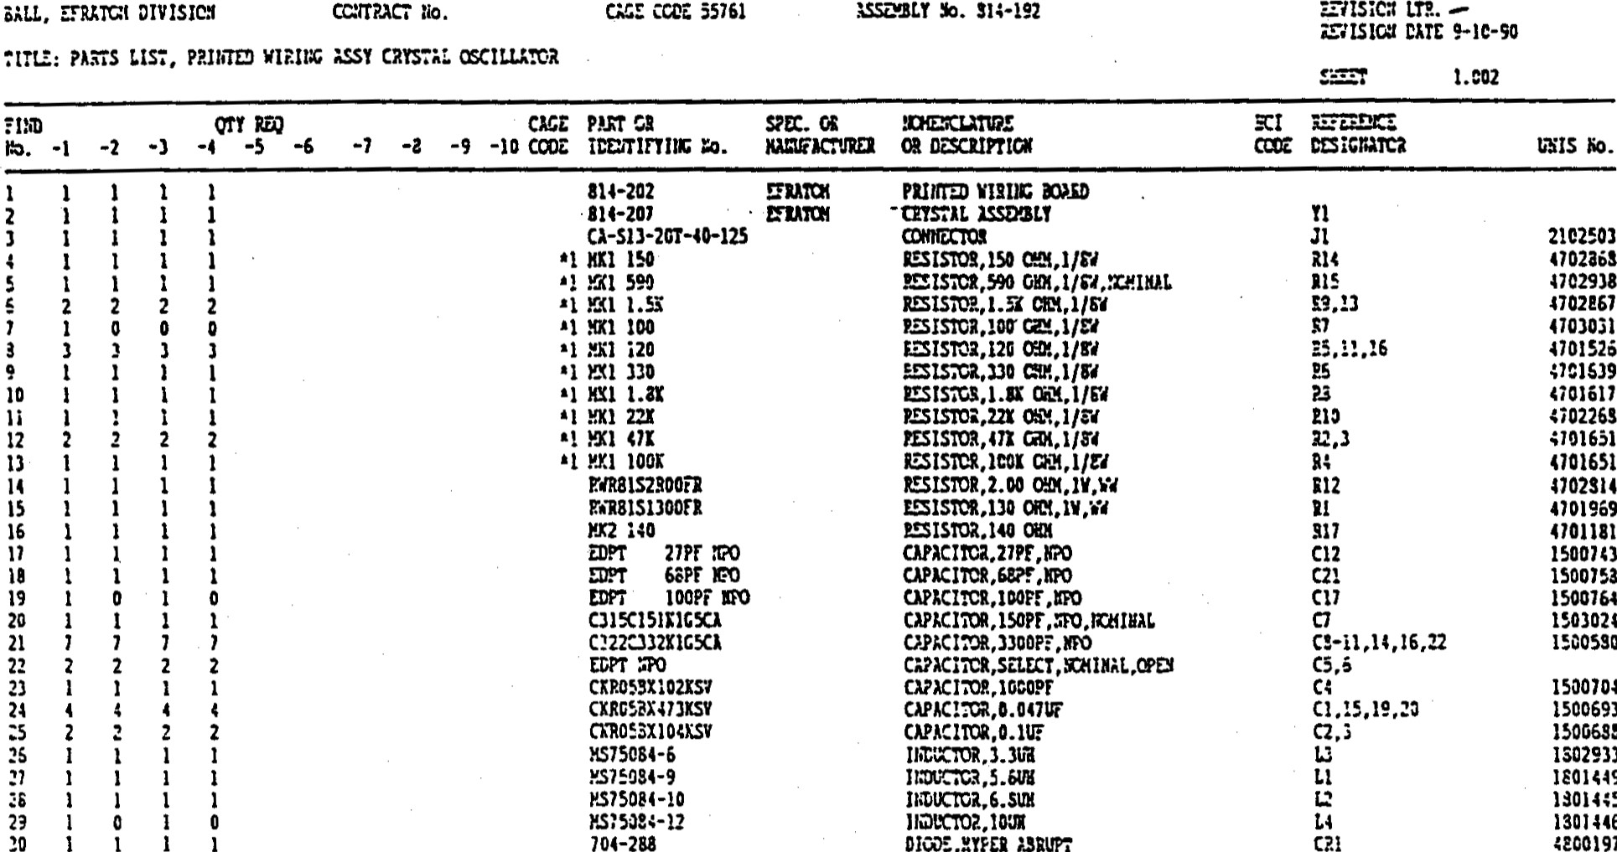1301446

1 1 704-288 DiCE,2YFE2 *.SRUPÎ 4200197

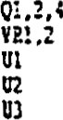 1 cm

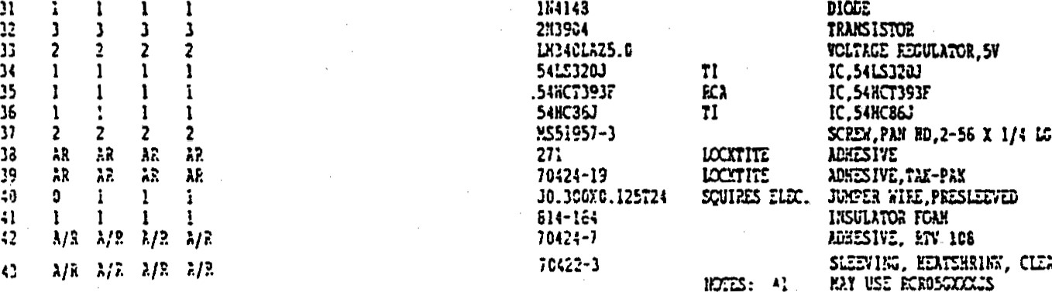

CI.ÎÂR

3131127

2621428

PARTS LIST,OSCILLATOR (A4) BOARD ASSENBLY (PL814-192/REV

A-25

NOTES: UNLESS orHERWlSE SPECIFIED.

WORKMANSHIP SHALL BE PER UlL-STD-4S4K REOUIREMENT 9. (NO CERTIFICATIONS REQUIRED)

1. SOLDERING. WIRING AND COMPONENT MOUWING MEET THE REOUIREUENTS OF Ipc-s-815 CUSS lit.
2. LEADS SHOULD BE PARTIALLY CUNCHED OR SW,'CED FOR PMT RETEFß10N

PRIOR TO SOLDERING.

 (FOR REF. ONLY SEE MIL-P-46B43B TWE OR

1. "TER SOLDERING. CLEAN ASSEMBLY XO REWÆ. aux RESIDUE.
2. IDENTIFY ASSEMBLY WITH ASSEMBLY NUMBER (AND DASH NO. 'F REQ'D). REMSION LETTER AND SERR NUMBER. 
3. LEAD PROJECTION BELOW BOARD SURFACE BE .020 MIN .060 

7. FOR SCHEMATIC DIAGRAM SEE DRAWINC NUMBER 814-16B

* 1. INSTALL ITEM 52 (TERMIB&US) J PLACES TP2. ASP!) FUNNEL SWAGE CIRCUIT SIDE PRIOR TO SOLDERING.
  2. •atw SHOWN ts FOR PCB 814-169 REV C ONLY

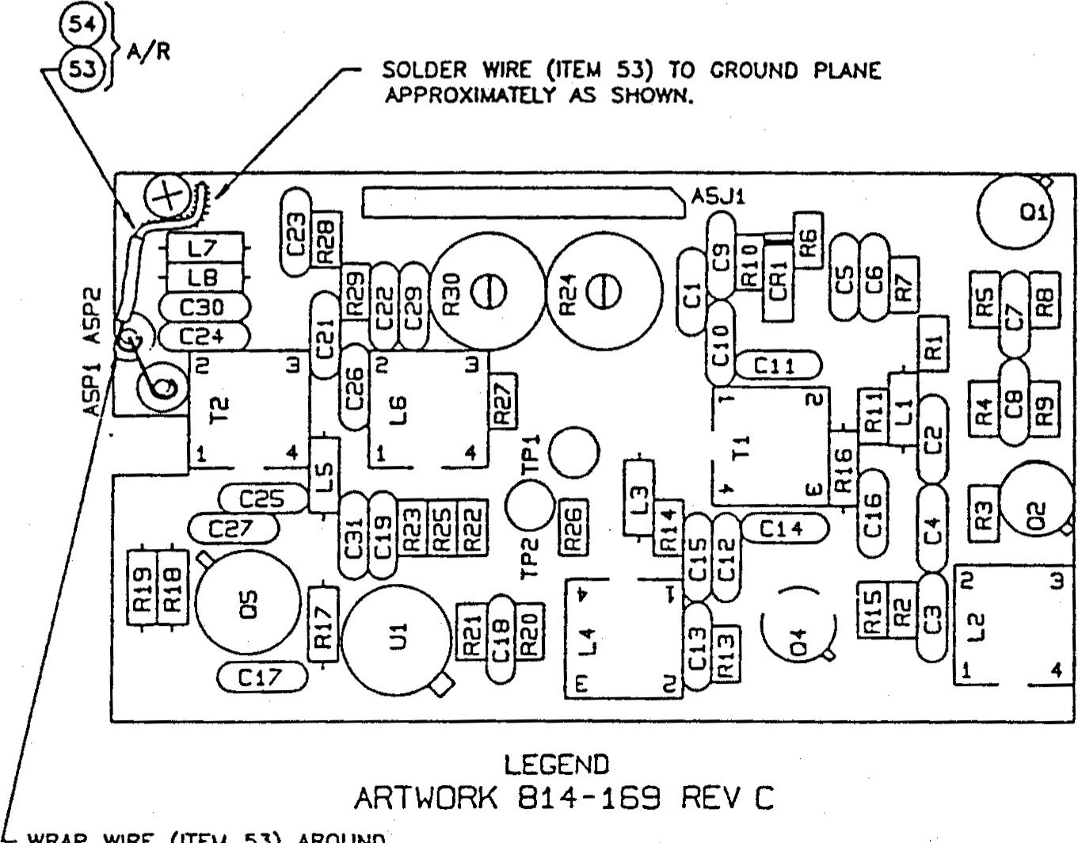WRAP WIRE (ITEM 53) AROUND COAX SHIELD AND SOLDER.

|  |  |
| --- | --- |
| TABULATION | |
|  | PARTS LIST |
| IOMHz TTL | 814-167-1 |
| 13MHz TTL | 814-167-2 |

ASSENBLY A5, MULTIPLIER BOARD (814-167/REV E)

A-26

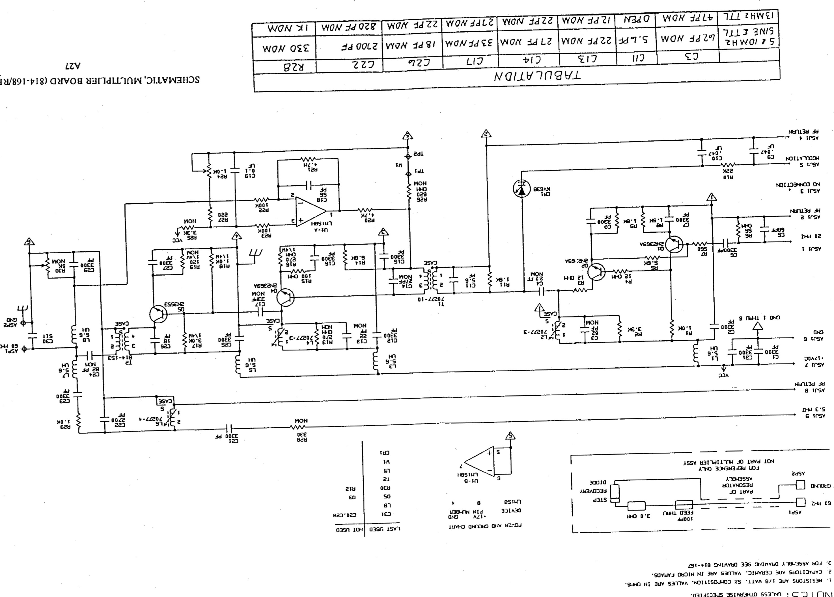

の

>

9E89

阜

一

S31

ロ

N

S 」



#### BALL, EFRATOM DIVISION CONTRACT No. CAGE CODE 55761 814-167-2 REVISION REVISION LTR. DATE -91-05-21



TITLE: PARTS LIST, 13HHZ MULTIPLIER BD ASSEMBL'Z

SHEET 2

#### REFERENCE

##### EFRATOM

2 A/R SN63FR}LAP3 QQ-S-571  SOLDER

#### 3 CA-S09-20T-40-125 CIRCUIT ASSY CONNECTOR, 9 PIN Ä5J1 2102502 4 1 EDPT 2.2 PFSTETTNER CAPACITOR, CER NO.Y 1503020



5 NOT USED

#### 6 2 EDPT 22NPO STETTNER CAPACITOR, CER NOM 1500742

7 NOT USED

#### 8 1 EDPT 12NPO STETTNER CAPACITOR, CER 12NOH C13 1500738 9 1 EDPT 27NPO STETTNER CAPACITOR, CER 27NOM C17 1500743 10 NOT USED

11 1 EDPT 56NPO serrrrNER CAPACITOR, CER 56  C18 1500753

#### 12 1 EDPTNPO STETTNER CAPACITOR, CER 68 150075B 13 1 EDPT NPO STETTNER CAPACITOR, CERPF NOM C24 1500760 14 1 EDPT 820 PF Y5P CAPACITOR. CER 820 PF NOM 1500796 15 14 C322C332KIG5CÄ CAPACITOR, CER 3300 PF 1500580



#### 16 2 CKR05BX473KS MIL-C-11015 CAPACITOR, CSR .047uF ce , 10 1500693 17 1 CKR05BX104KS MIL-C-i1015 CAPACITOR, CER C19 150068B 18 1 EDPT (SELECT) STZTTMER CAPACITOR. CSR szzzcr C30 19 1 KV63B DIODE, VARÄCTOR CRI 4800966 20 5 MS75084-9 INDUCTOR, 5.6UH, L3 , 1.7-8 1801449





21 2 70277-3 EFP-ATOM INDUCTOR, VARIÄBLZ 1.2 , r.,4

#### 22 70277-4 ZFRÄTOM IEDUCTOR, VARIABLZ

23 3 2N2369A TRANSISTOR; NP.N4800190

 1 2N3553 TRANSISTOR, NPN 4800195

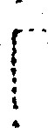25 2 RCR05G120JR RESISTOR.  4701525 26 1  RCR05G560JR RäSISTOR, 4701656 27 1 RCR05G101JR RESISTOR. R15  4701599 28 1 RCR05C271JR RES I STOR ,NOM 4701632 29 1 RCROSC22iJR RESISTOR, R27 4701627

30 NOT USED

#### 31 1 RCR05C561JR RESISTOR, 560 ons 27 4702263 32 3 RCR05G102JR RESISTOR,4701600 33 RCR05Gi52JR RESISTOR, 1.5K < 701527

1

PARTS LIST, MULTIPLIER (A5) ASSENBLY (PL814-167/REV (PAGE 1 OF 2) 

A-28

BALL, EFRATOM DIVISION CONTRACT No.

TITLE: PARTS LIST, i3MHZ MULTIPLIER BD CAGE CODE 5S761 814-167-2 REVISION LTR. -

ASSEMBLY

##### REVISION DATE 91-05-21

SHEE'r 3

FIND QTY PART OR SPEC. OR NOMENCLATURE REFERENCE

NO. REQ IDENTIFINC No. NANUFACTURER OR DESCRIPTION DESIGNATOR UNIS No .

#### 34 2 RCR05GiB2JR RESISTOR, 1/8W 1.8K 4701617

2 RCR05G332JR RESISTOR, 1/8W 3.3K R2, (R25 NOH) 4701640

#### 36 1 RCR05G472JR RESISTOR, I/BW 4.7K R20 4702265 37 1 RCR05C562JR RESISTOR. 1/8W 5.6K 4701657 38 1 RCR05G682JR RESISTOR, 1/8W 6.8K R14 4702604 39 2 RCR05G104jR RESISTOR, 100K R22 , R23 4701602 40 1 RCR05C223JR RESISTOR. 1/8W 22K RIO 470226B 41 RCR05G475JR RESISTOR. 1/8W 4 .7M R21 4701550 42 1 RCR07C121JR RESISTOR, 1/4W 120 OHN NOM R19 4701691 43 1 RCR07G27iJR RESISTOR, 1/4W 270 OHM RIG 4701714 44 1 RCR07C102JR RESISTOR, 1/4W 1.0K RIB 4701686 45 1 RCR07G302JR RESISTOR, 3.0K 4701716 46 1 RCR05G821JR RESISTOR, i/8W 820 OHY. R26 4702264 47 1 33B6P-1-102 BOURNS RESISTOR, VAR 1.0K 224 4750253

48 1 70277-10 EFRÄTOM TANSFORMER

#### 49 1 814-153 EFRÄTOM TRANSFORMER 50 1 LM15BH NATIONAL l.c. OP-AMP 3130993 51 1 CCR05CG4 7 OUR CAPACITOR CER e. 7 PF NOH 1502522 52 3 M55155/30-09 MIL-T-55155 TERMINAL , TP2 ,Ä5Pi 2101101 53 QQ-W-343S24SIT QQ-W-343 WIRE, 24ÄWG. BGSS 54 24 GATWTFL SLEEVING, 24A*C, AMS-3655 55 NOT USED 56 1 3339P-1-502 RESISTOR, VAR, 5K NOM R30 4750249

57 3 7717-46M PAD, TRANSISTOR  2102342

#### 58 1 5203-11 PAD, TRANSISTOR XQ5 3100370

 1. USE MKI RES IF RCR05CXXXJR UNAVAIL.

o 2. USE MX2 RES IF RCR07GXX.XäS tiNÄVAIL.

PARTS LIST, MULTIPLIER (A5) ASSENBLY (PL814-167/REV (PAGE 2 OF 2)

A-29

### APPENDIX B

FRS MONITORS AND ADJUSTMENTS AT CONNECTOR Jl

Lamp Voltage Monitor,

Crystal Control Voltage Monitor, and External Frequency Adjustments

Lamp Voitage Monitor

When the FRS unit is assembled its lamp voltage is set at the factory to —14 volts. Over the first year of operation this voltage level will decay by 2 to 3 volts. After the first year of operation this decay i becomes much less. The decay can go as low as 6 volts before the operation of the unit is affected.

Lamp voltage levels also vary depending on the state of the unit. When a FRS is first powered up the lamp voltage is between 1.5 to 3 volts. Once the rubidium lamp ignites, lamp voltage rises to between 14 to 9 volts in a working unit, depending on its operating duration. ms voltage change is used to switch the FRS internal regulated power supply from 22 to 17 Vdc. 'Ihe lamp requires 22 volts to ignite, but after ignition only 17 volts is required to maintain operation.

Functionally, the lamp monitor circuit measures the lamp voltage through a I megOhm resistor (that protects the lamp circuit). The reading will change depending on the input impedance of the voltage measuring device. The higher the input impedance, the more accurate the measurement will be. The resistor and the input impedance for a voltage divider that reduces the measured voltage.

NOTE:

The lamp voltage monitor is for factory use and reference only, and is not intended as customer use. If there is a special requirement that makes it necessary to monitor the lamp voltage level in the field, the customer should contact Efratomts Marketing or Customer Service groups so that Efratom's technical staff can evaluate these needs and make recommendations.

Crystal Voltage Monitor

fie crystal voltage controls the crystal oscillator output frequency through the error signal, slaving the oscillator output to the atomic frequency. As the unit warms up the crystal voltage sweeps the oscillator frequency to detect the atomic frequency signal. 'Ihe voltage range of these sweeps is between I .5 and 12 volts dc. Upon detecting the atomic frequency the unit locks and the monitor circuit automatically controls the crystal voltage at the level necessary to lock the output signal to the atomic frequency. Generally, this is any voltage from 2 to 10 volts (but typically 4 to 8 volts), depending on conditions.

The lock monitor is normally used by Efratom as an indication that the output frequency is locked to the atomic frequency. In this use, the lock monitor signal supercedes both the lamp voltage and crystal voltage as a failure indication.

NOTE:

The crystal voltage monitor is for factory use and reference only, and is not intended as customer use. If there is a special requirement that makes it necessary to monitor the crystal voltage level  in the field, the customer should contact Efratom's Marketing or Customer Service groups so that Efratorn's technical staff can evaluate these needs and make recommendations.

External Frequency Adjustment

The external frequency adjustment feature allows the user to change the output frequency of the FRS over a range of to ±1.5 x IOE-9 using a customer supplied 1000 Ohm potentiometer, or placing O to +5 volts across the external connector pins (from a customer supplied source). When a potentiometer is used, pins 2 (wiper), 3 and 8 (ends) are connected. For 0 to +5 volts, pins 2(+) and 3 (gnd) are used.

When either of these two methods are used, they will override the setting of the internal frequency adjustment.

The following figures show simple schematics of the external frequency adjustment connections.

#### FRS

External

Connector

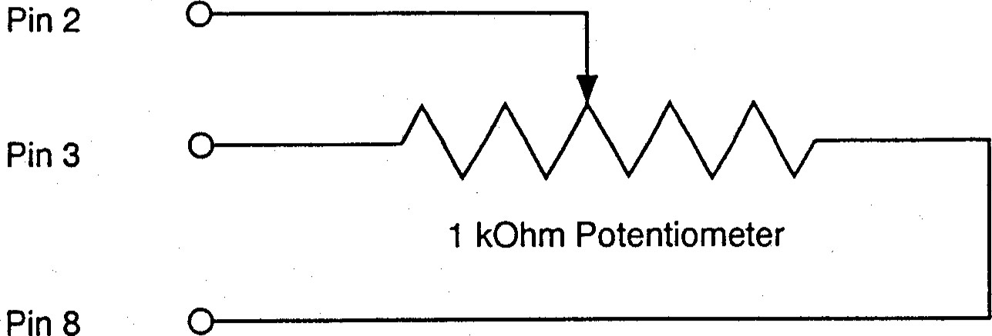

Figure B l . Potentiometer Connections 

0 to +5 Volt Connections

Voltage Source

|  |  |
| --- | --- |
|  | O to +5 Volts  - (gnd) |
|  |
|  |

Pin 2

Pin 3

Figure B2. 0 to +5 Volt Connections



'The seller warrants that each article of goods sold by it will at the time of shipment be free from defects in materials furnished and workmanship perfonned by the seller. This warranty and sellers liability are limited to either granting credit or repairing or replacing, at seller's option, with reasonable promptness after return to seller of any article which is disclosed to sellers satisfaction to be defective, and only if said is retumed to the seller promptly after discovery of such defect and in no event later than 12 months (or such other time period as may be specified in witing as a warranty period for a particular article) from the date of delivery thereof. Nonnal transportation charges in connection with an article returned shall be at the sellers expense, but only if the seller is responsible under the terms of this warranty. 'Ihis warranty does not extend to any article which has been subject to misuse, neglect, or accident, nor does it extend to any article which has been repaired or altered by other than the seller. TYIS WARRANTY IS IN LIEU OF ALL OTHER WARRANTIES EXPRESSED OR IMPLIED, INCLUDING ANY WARRANTY OF

FITtsESS FOR A PARTICULAR PURPOSE AND THE RIGHTS AND RENEDES PROV'IDED HEREIN ARE  EXCLUSIVE AND m LIEU OF ANY OTHER RIGHTS OR REMEDIES. NO EVENT SHALL SELLER BE LIABLE FOR CONSEQUENTIAL DAMAGES."

Efratom Time & Frequency Products, Inc. will be happy to answer any application or usage questions which will enhance your use of the unit. Please address your requests or correspondence to: EFRATOM Time & Frequency

Products, Inc., 3 Parker, Irvine, California 92718-1696, Attention: Sales Department, or call (714) 770-5000, Fax: (714) 770-2463.

European customers may contact: Efratom Elektronik GmbH, Fichtenstr 25, 85649 Hofolding, Germany, Telephone: 0810466240; Telex 529701; Fax: 08104-6622428.

t" 

0 1995 EFRATOM Time & Frequency Products, Inc. All rights reserved.